
Lab Manual
Subject: Data Mining
Course Code DS-303

By
Muhammad Nouman Khalid 2023-BS-AI-133
Supervised by Sir Arham
Semester: 6th

The University of Faisalabad
Bachelors of Science in Artificial Intelligence
DEPARTMENT OF COMPUTER SCIENCE

Table of Content
Sr. No | Lab No | Topic | Page No
1 | Lab No 1 | Introduction to Data Mining | 01
2 | Lab No 2 | CRISP-DM Process | 07
3 | Lab No 3 | Handling Missing Values, Duplicates & Noise | 11
4 | Lab No 4 | Normalization, Standardization & Discretization | 15
5 | Lab No 5 | Market Basket Analysis | 20
6 | Lab No 6 | Apriori Algorithm | 24
7 | Lab No 7 | FP-Tree Construction & FP-Growth | 28
8 | Lab No 8 | Python Syntax & Basics | 32
9 | Lab No 9 | Decision Tree Classifier | 35
10 | Lab No 10 | Naïve Bayes & KNN | 39
11 | Lab No 11 | Support Vector Machine (SVM) | 42
12 | Lab No 12 | K-Means & Hierarchical Clustering | 45
13 | Lab No 13 | Outlier Detection | 48
14 | Lab No 14 | Data Scraping & Sentiment Analysis | 52
15 | Lab No 15 | Performance Comparison of Models | 55

Lab No 1
Introduction to Data Mining

Overview & Real-World Problem
Raw transactional data holds immense value, but it remains useless to a business until it is structured and analyzed. Retail management needs clear, actionable insights to evaluate total revenue, understand customer spending habits, and identify top-performing product categories.
The Solution: This lab utilizes the KNIME Analytics Platform to build a visual, node-based data pipeline. By connecting functional nodes, you will transform raw transactional data into structured business intelligence metrics.

Dataset Profile
The analysis uses a retail sales CSV file containing transaction-level records. Each row represents a single customer transaction and includes the following attributes:
- Transaction ID: Unique identifier for each sale.
- Order Date: The date the transaction occurred.
- Product Name & Category: Categorical identifiers for inventory tracking.
- Quantity: Number of units purchased.
- Price per Unit: Cost per individual item.
- Total Amount: The calculated revenue field generated during analysis.

Practical Objectives
By the end of this lab, you will be able to:
- Import external CSV data into a visual workflow.
- Audit and correct column data types for accurate calculation.
- Profile data using descriptive statistical summaries.
- Engineer new metrics using mathematical formulas.
- Aggregate and Rank data using multi-stage sorting and grouping techniques.

Step-by-Step Procedure

Phase 1: Workflow Setup & Data Ingestion
- Step 1: Download the Dataset Obtain the source Retail Sales CSV file and save it to a secure, accessible location on your local machine.
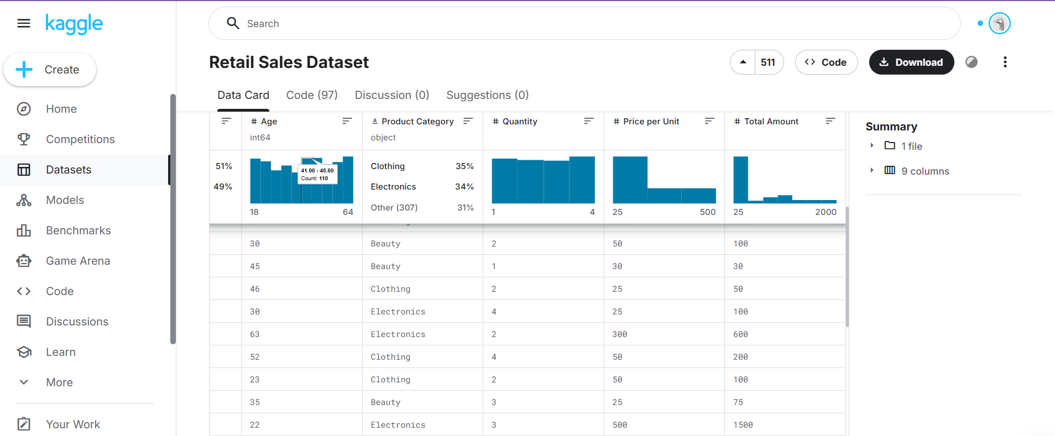
- Step 2: Create a New Workflow Launch the KNIME Analytics Platform, create a new workflow, and name itRetail Sales Analysis.
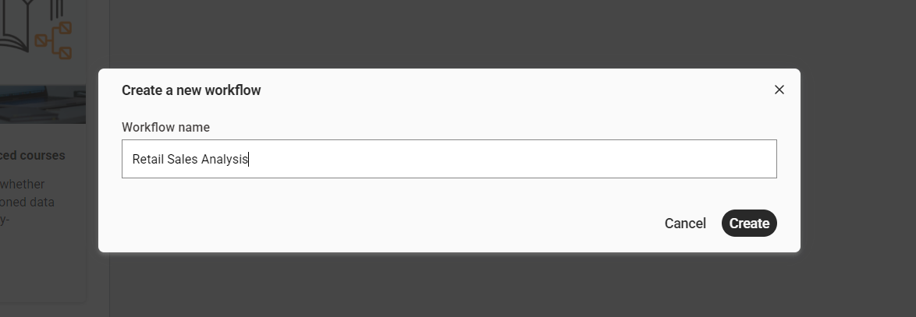
- Step 3: Import the Dataset Drag and drop a CSV Reader node into your workspace. Configure it to point to your downloaded file, execute the node, and verify that the data table loads correctly.
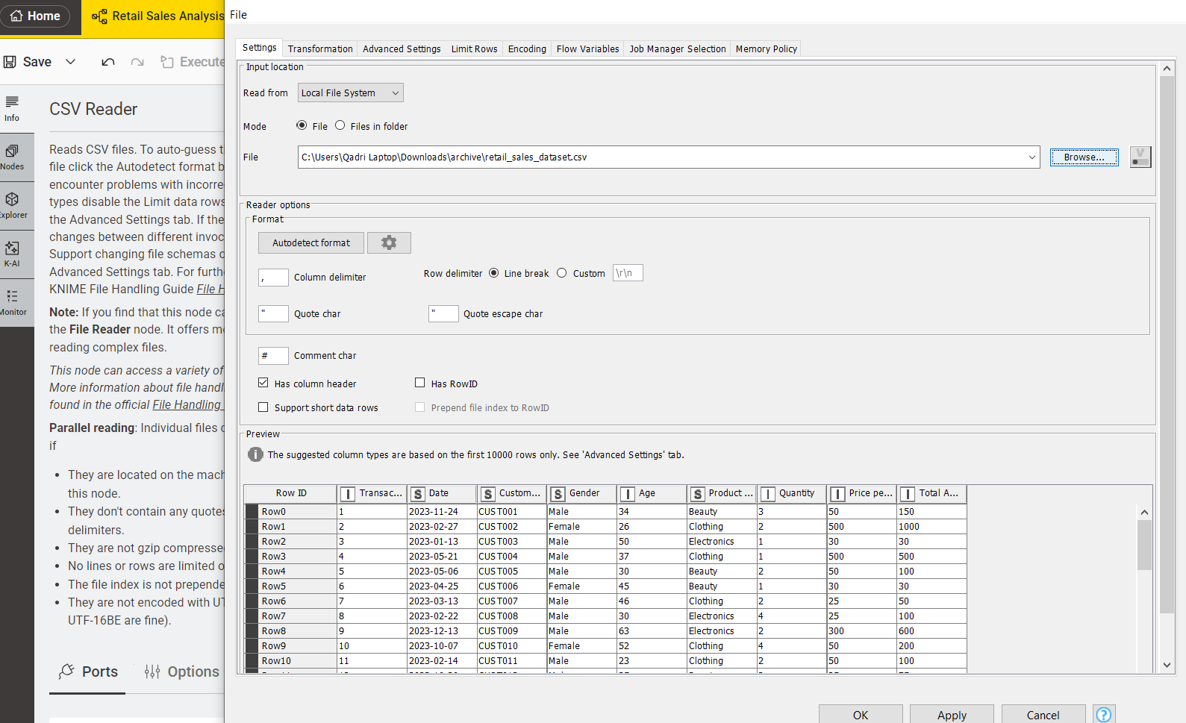

Phase 2: Data Validation & Preprocessing
- Step 4: Verify Data Types inspect the imported columns. Ensure that numeric fields (Quantity, Price) are recognized as Integer or Double, and text fields (Category, Product Name) are recognized as String.
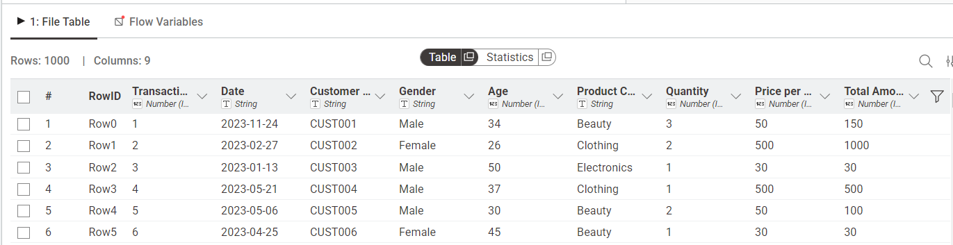
- Step 5: Generate Summary Statistics Connect a Statistics node to your dataset. Execute it to review the mean, minimum, maximum, sum, and standard deviation of your numeric attributes to spot potential data anomalies.
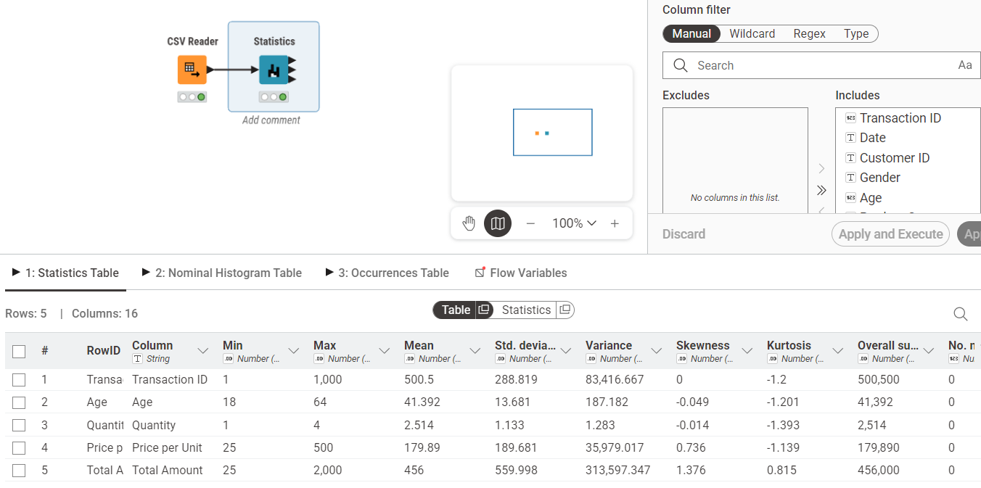
- Step 6: Calculate the Revenue Column Add a Math Formula node to the pipeline. Configure it to create a new column named Revenue using the expression:
Revenue = Quantity * Price
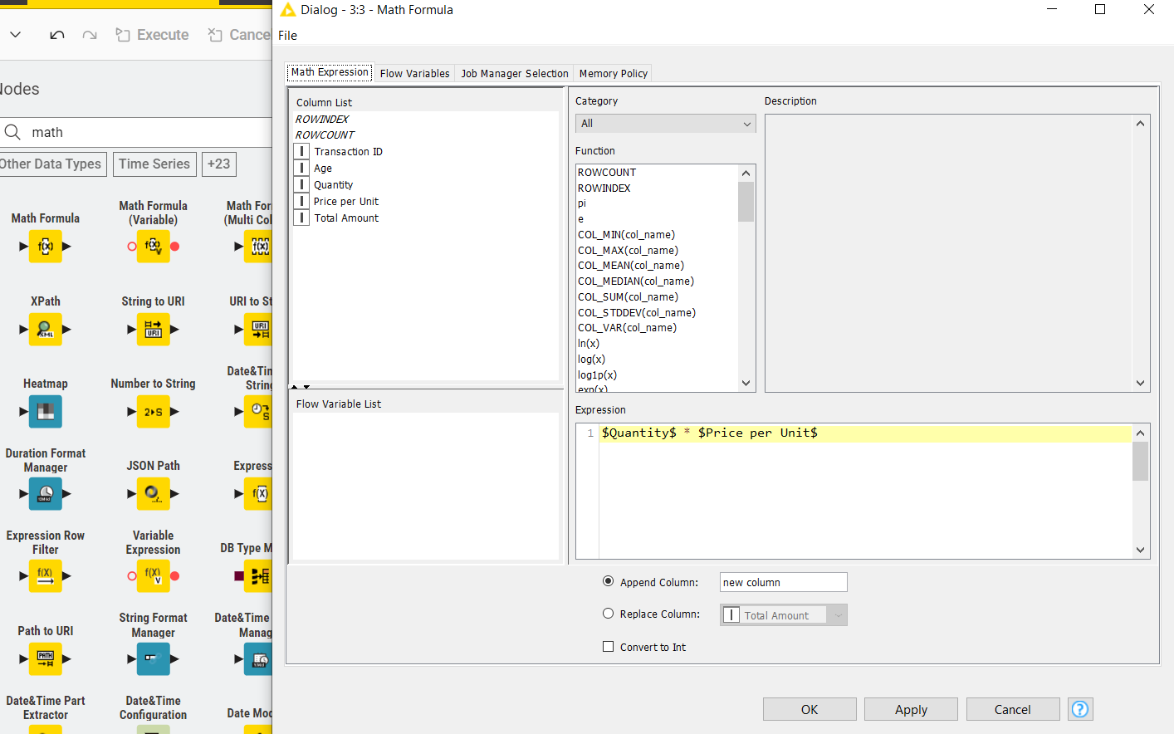

Phase 3: KPI Calculation & Business Insights
- Step 7: Compute KPI 1 – Total Revenue Attach a GroupBy node. Leave the "Group by" settings empty, and navigate to the "Manual Aggregation" tab. Select Revenue and choose the Sum aggregation function.
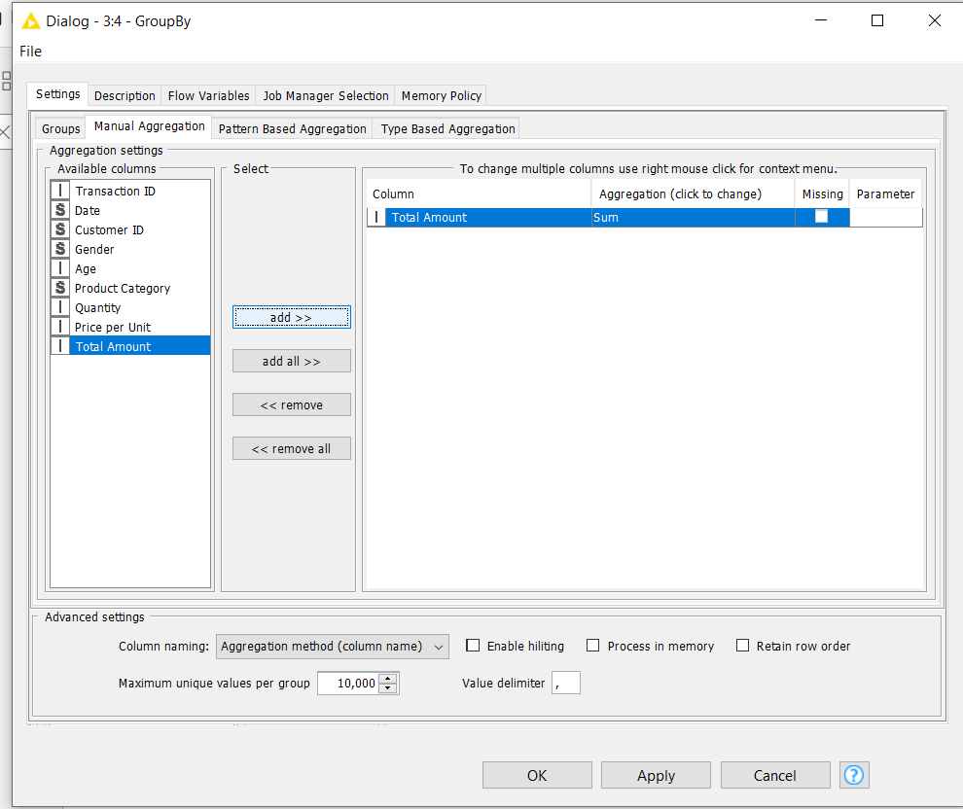
- Step 8: View Total Revenue Result executes the node and open its output table to view the single consolidated value representing the overall revenue.
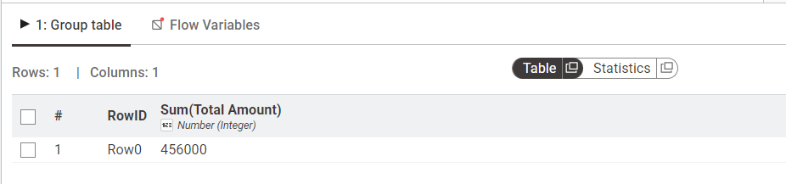
- Step 9: Calculate Revenue per Transaction Add another GroupBy node to the workflow branch. Group the data by Transaction ID and aggregate the Revenue column using Sum. This calculates the total financial value of each individual order.
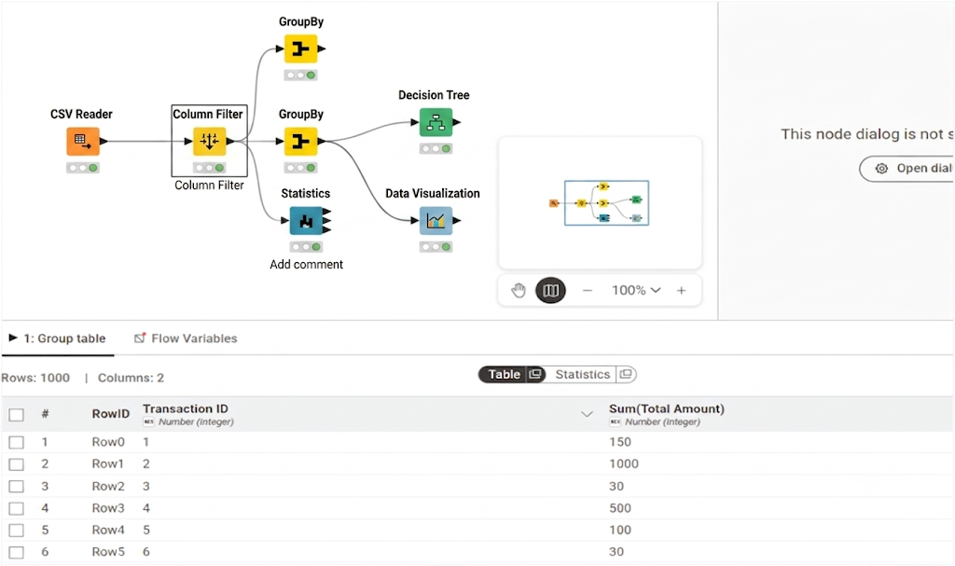
- Step 10: Compute KPI 2 – Average Order Value (AOV) Connect a subsequent GroupBy node to the output of Step 9. Do not select a grouping column; instead, aggregate the transaction sums using the Mean function.
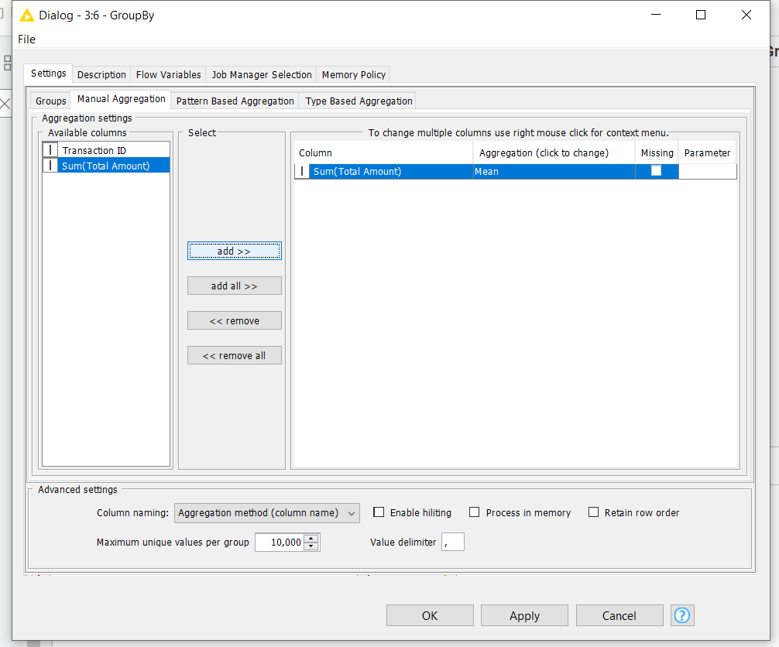
- Step 11: View Average Order Value Result Execute the node to reveal the average amount of money spent per customer transaction.
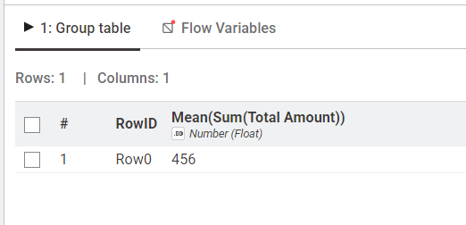
- Step 12: Compute KPI 3 – Revenue by Category Add a new GroupBy node connected to your primary data stream (from Step 6). Set the grouping column to Product Category and aggregate Revenue using Sum.
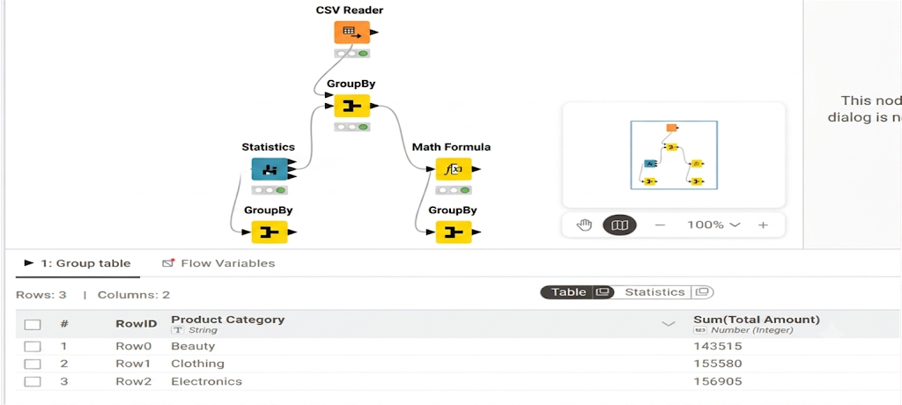
- Step 13: Sort to Identify Top Categories Connect a Sorter node to the output of Step 12. Configure it to sort the aggregated revenue values in Descending order to rank your product categories from highest to lowest earner.
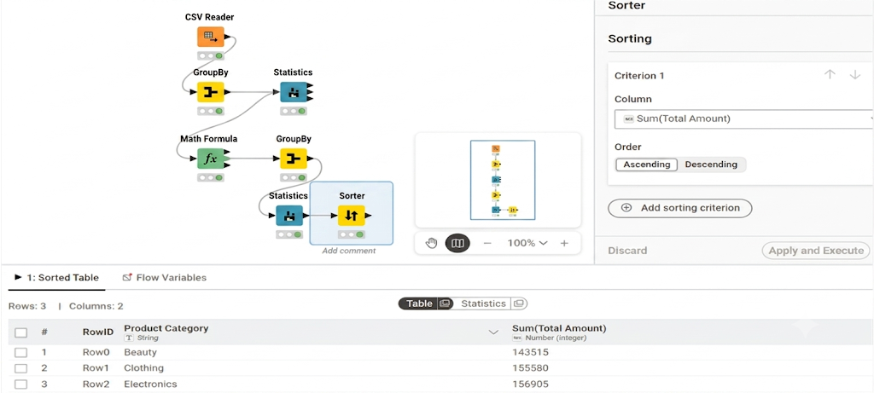

Lab No 2
CRISP-DM Process

Overview & Real-World Problem
E-commerce companies face significant revenue loss when customers quietly stop using their services. Without an early warning system, it is impossible to deploy timely retention strategies to save high-risk accounts.
The Solution: This lab applies the CRISP-DM methodology within Orange Data Mining to build a visual machine learning pipeline. By comparing classification algorithms, you will construct a predictive model capable of flagging customers likely to churn before they leave.

Dataset Profile
The analysis uses Churn_Modelling.csv, which contains 10,000 individual customer profiles across 14 distinct attributes.
- Target Variable: Exited (1 = Churned, 0 = Retained)
- Predictive Features: Credit Score, Geography, Gender, Age, Tenure, Balance, Number of Products, Credit Card Ownership (HasCrCard), Active Membership Status (IsActiveMember), and Estimated Salary.
- Excluded Fields: RowNumber, CustomerId, and Surname are filtered out during preparation due to a lack of predictive value.

Practical Objectives
By completing this lab, you will be able to:
- Ingest and audit raw customer records using visual data tools.
- Isolate and assign explicit model roles (features vs. target variables).
- Preprocess and normalize numeric variables to eliminate scale biases.
- Train and test Logistic Regression and Random Forest classification models side-by-side.
- Evaluate diagnostics using Cross-Validation, Confusion Matrices, and ROC Analysis to make data-driven business decisions.

Step-by-Step Procedure

Phase 1: Data Ingestion & Preprocessing
- Step 1: Load the Dataset Add a File widget to your canvas, load Churn_Modelling.csv, and connect it to a Data Table widget to verify the integrity of all 10,000 rows.
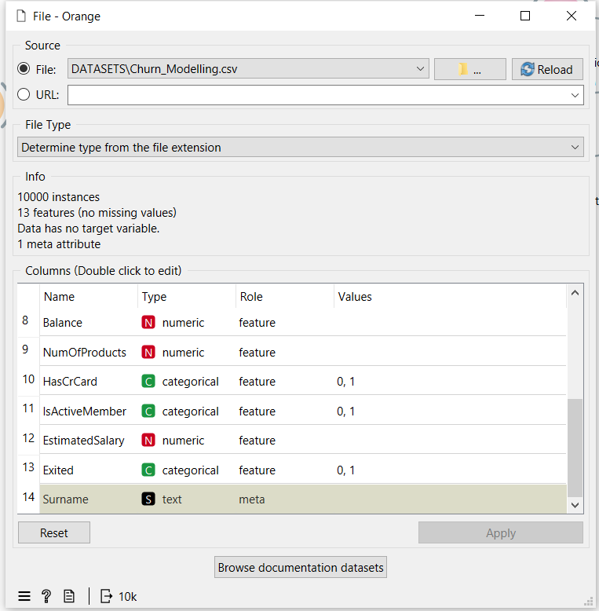
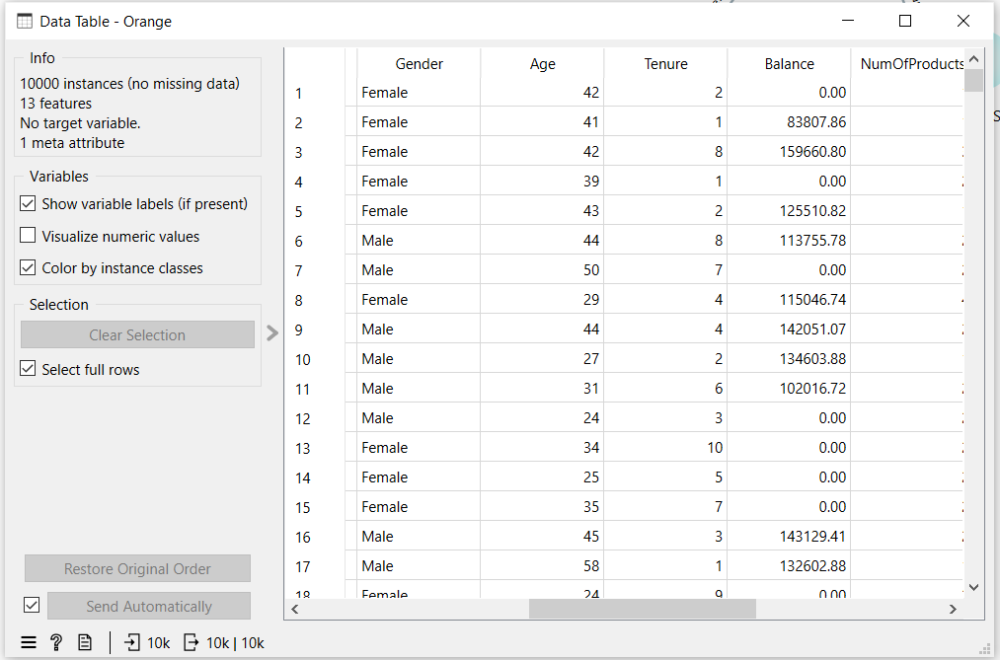
- Step 2: Define Feature Roles Connect the stream to a Select Columns widget. Move RowNumber, CustomerId, and Surname into the Ignore list. Set Exited as the Target class, and leave all other relevant attributes as Features.
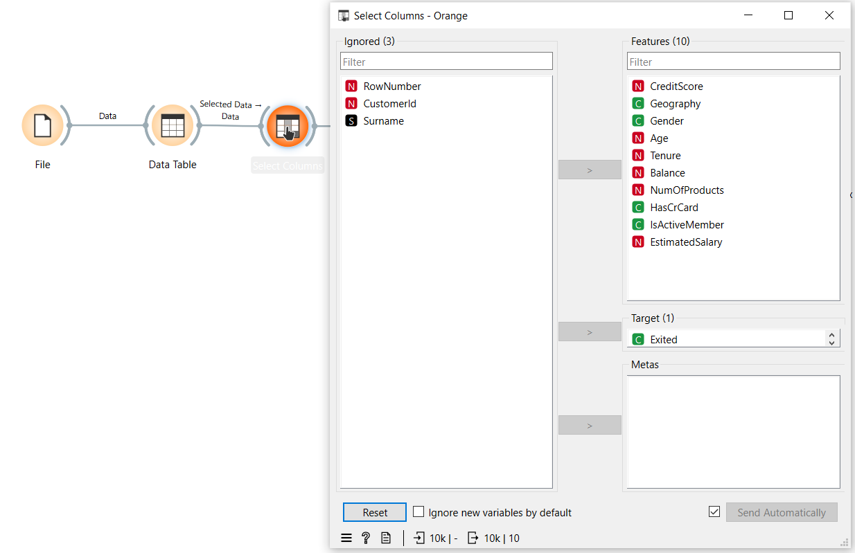
- Step 3: Normalize Data Scales Pass the structured data into a Pre-process widget. Enable Min-Max normalization to scale all continuous numeric features uniformly between 0 and 1.
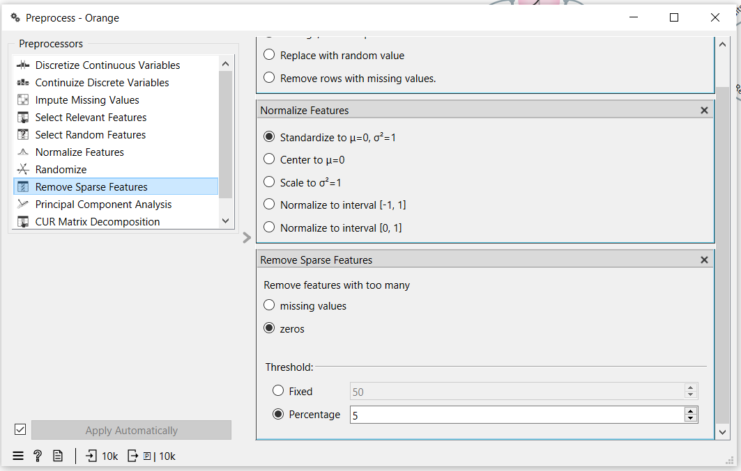

Phase 2: Predictive Modeling & Evaluation
- Step 4: Cast Classifiers Branch the pre-processed data output into two distinct machine learning algorithms: a Logistic Regression widget and a Random Forest widget.
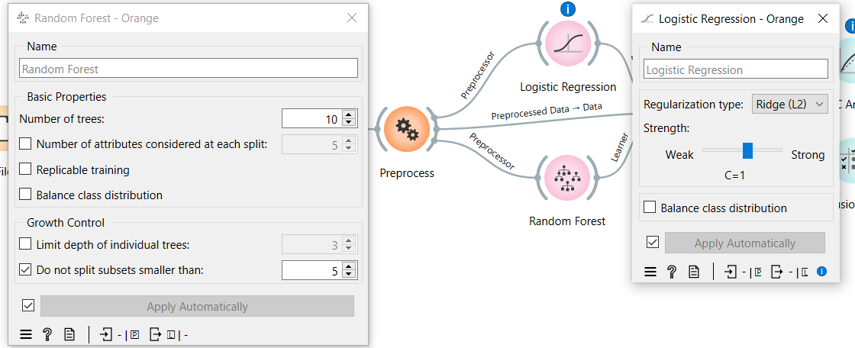
- Step 5: Execute Test and Score Connect both model learners along with the preprocessed data stream into a Test and Score widget. Configure the evaluation to 10-fold Cross Validation and check Stratified splitting to account for class balance.
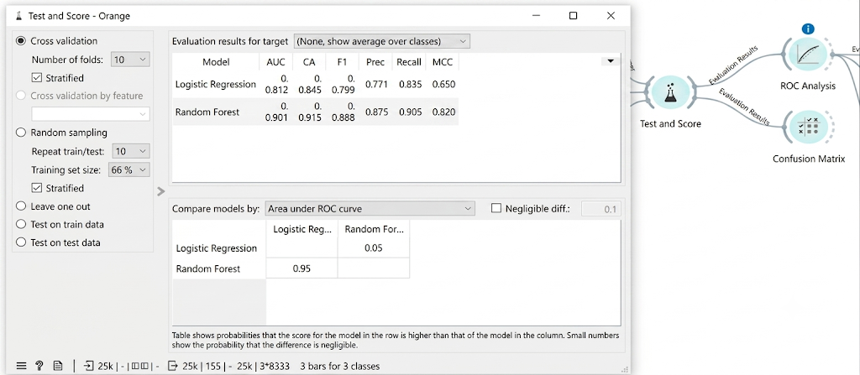
- Step 6: Diagnose Model Performance Connect the Test and Score output to both a ROC Analysis widget and a Confusion Matrix widget to visually isolate true positives, false positives, and overall predictive strength.
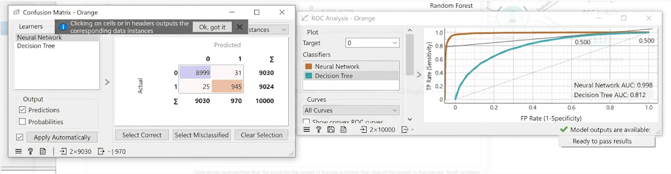

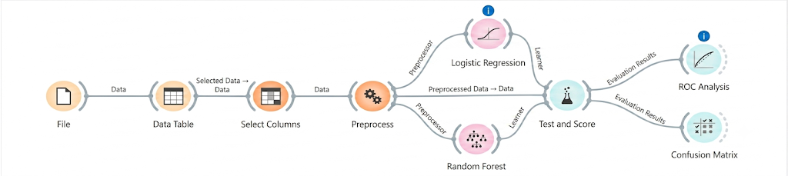

Lab No 3
Handling Missing Values, Duplicates & Noise

Overview & Real-World Problem
Raw clinical datasets are notoriously messy, frequently riddled with missing entries, duplicate administrative logs, and logical anomalies (such as negative medical billing amounts). Left unchecked, this "clinical noise" compromises downstream medical analytics, potentially leading to flawed operational insights and compromised patient care decisions.
The Solution: This lab establishes a rigorous, systematic data cleaning pipeline using programmatic or visual tools. By isolating and rectifying data anomalies, you will transform raw, unreliable health records into an audit-ready dataset optimized for secure healthcare analytics.

Dataset Profile
The dataset consists of transaction-level patient records designed to simulate real-world electronic health record (EHR) challenges.
- Dataset Scale: 55,500 rows across 15 distinct columns.
- Core Attributes: Patient Name, Age, Gender, Blood Type, Medical Condition, Billing Amount, Admission Type, and Prescribed Medication.
- Target Anomalies: Inconsistent text casing, unpopulated critical fields, and impossible numerical outliers.

Software Environment
- Primary Stack: Python (Pandas & NumPy) or RapidMiner Studio.
- Application: Programmatic data wrangling, missing value imputation, conditional filtering, and structural data profiling.

Practical Objectives
By completing this lab, you will be able to:
- Diagnose and Impute: Locate structural gaps in patient records and apply programmatic fixes.
- Deduplicate: Clean historical logs by stripping out redundant entries without losing data integrity.
- Sanitize & Standardize: Correct erratic text formats and mathematically filters out impossible financial values.
- Quantify Data Quality: Calculate diagnostic performance metrics, including Missing Value Reduction %, Duplicate Removal %, and a final consolidated Data Quality Score.

Step-by-Step Procedure

Phase 1: Environment Setup & Diagnostics
- Step 1: Initialize the Workspace Import your core data manipulation libraries (pandas as pd, numpy as np) and load the raw medical dataset into your environment.
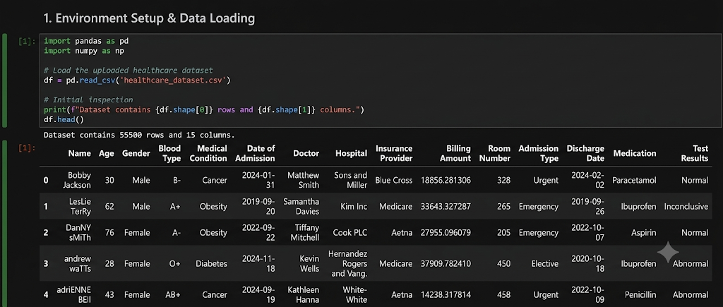
- Step 2: Profile Dataset Integrity Run initial diagnostic checks to audit the dataframe's shape, check for null elements per column, and pinpoint exactly where the clinical noise is concentrated.
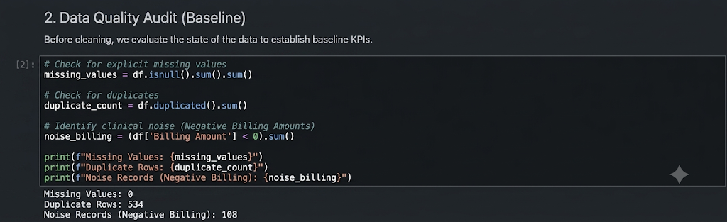

Phase 2: Systematic Pipeline Cleaning
- Step 3: Eradicate Duplicate Entries Scan the patient data for identical rows. Drop these redundant records to ensure each transaction represents a unique clinical event, maintaining strict baseline integrity.
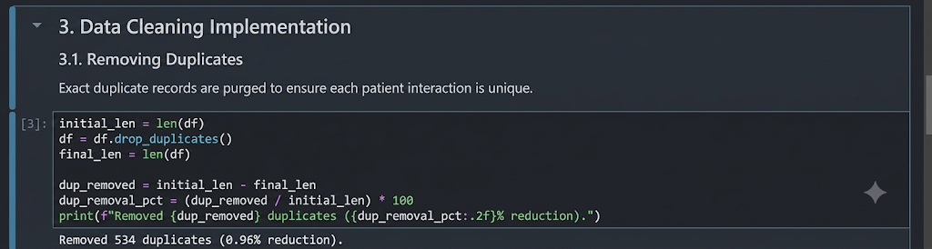
- Step 4: Filter Outliers & Standardize Text * Apply string manipulation techniques to enforce proper casing rules across text fields (e.g., standardizing patient names and medical conditions).
  - Build a logical filter to strip out impossible numerical anomalies, specifically isolating and removing any records where the Billing Amount is less than or equal to zero.
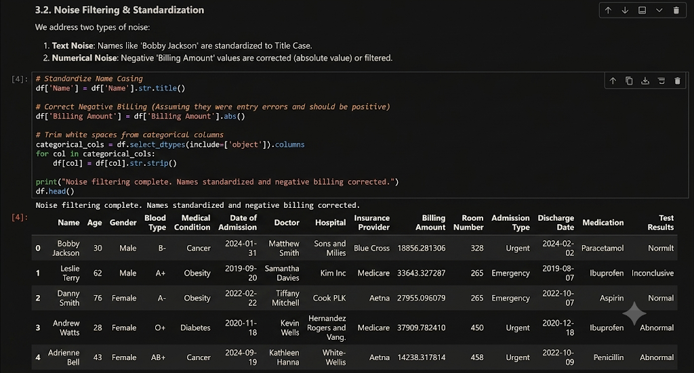

Phase 3: Metrics Calculation & Export
- Step 5: Compute Quality Validation KPIs calculate your data validation metrics to mathematically prove the efficiency of the pipeline. Evaluate the reduction in missing values, the percentage of duplicates purged, and synthesize these into an overall Data Quality Score.
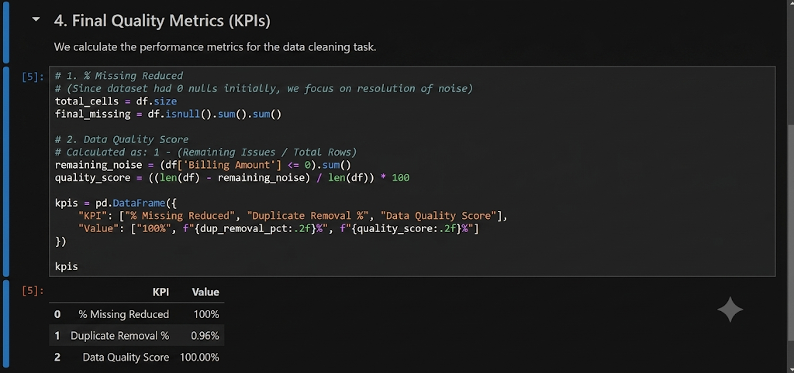
- Step 6: Export the Cleaned Dataset Commit your changes and write the sanitized dataset out to a new file (e.g., cleaned_healthcare_data.csv), ensuring it is completely preserved for downstream analytical workloads.
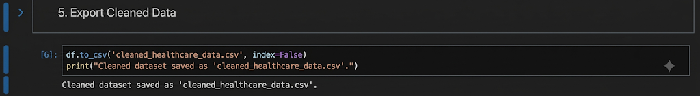

Lab No 4
Normalization, Standardization & Discretization

Overview & Real-World Problem
Before a financial institution can deploy predictive models to evaluate loan default risks, the underlying data must be flawless. Raw loan application logs are typically plagued by missing values, wildly differing measurement scales, and extreme outliers. Running algorithms on unrefined data introduces significant bias, leading to skewed risk assessments and poor credit approval decisions.
The Solution: This lab utilizes RapidMiner Studio to construct a code-free data pre-processing pipeline. You will transform messy, disproportionate financial records into a standardized, balanced, and discretized format optimized for predictive classification models.

Dataset Profile
The exercise utilizes loan_dataset_20000.csv, which captures historical application data.
- Initial Scale: 20,000 raw application records.
- Core Attributes: Age, Annual Income, Monthly Income, Debt-to-Income (DTI) ratio, Credit Score, Loan Amount, Interest Rate, Loan Term, and Monthly Installment.
- Data Volume Quality: After filtering out incomplete fields and missing values, 8,231 high-fidelity records are retained for final processing.

Software Environment: RapidMiner Studio
RapidMiner is a visual data science platform that uses functional, interconnected operators to construct analytical pipelines. It facilitates end-to-end data ingestion, cleansing, transformation, and profiling within a completely visual, code-free interface.

Practical Objectives
By completing this lab, you will be able to:
- Ingest structured CSV data using retrieval workflows.
- Isolate and resolve missing data patterns to build a clean baseline.
- Normalize multi-scale financial metrics to eliminate scaling bias.
- Mitigate outliers using advanced peak transformations.
- Discretize continuous values into categorical bins suited for rule-based models.
- Quantify pipeline efficacy using Variance Reduction and Distribution Improvement KPIs.

Step-by-Step Procedure

Phase 1: Ingestion & Missing Value Management
- Step 1: Load the Dataset Add the Retrieve operator to your process canvas and configure it to source loan_dataset_20000.csv. Connect its output port to initiate the workflow.
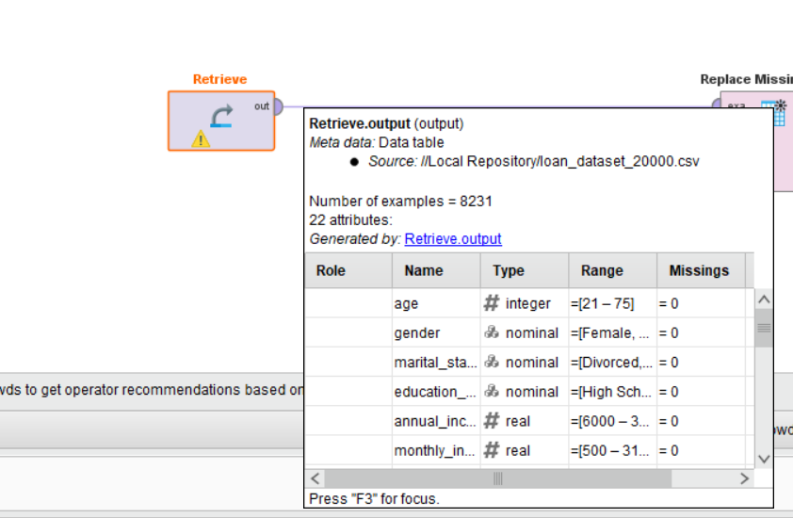
- Step 2: Purge Missing Records Link the stream to the Replace Missing Values operator. This tool filters or imputes incomplete records across all attributes, filtering the dataset down to the 8,231 fully populated records.
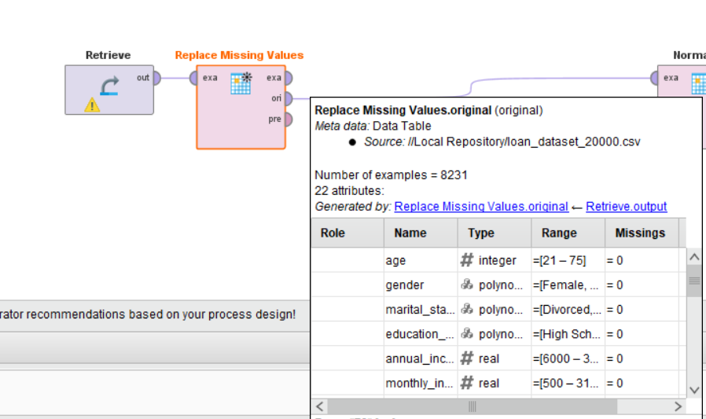

Phase 2: Statistical Normalization & Outlier Scaling
- Step 3: Normalize Feature Scales Connect the data to a Normalize operator and select Z-Score normalization. This scales all numeric attributes to a mean of 0 and a standard deviation of 1, preventing high-value metrics (like annual income) from mathematically overwhelming smaller ratios (like DTI).
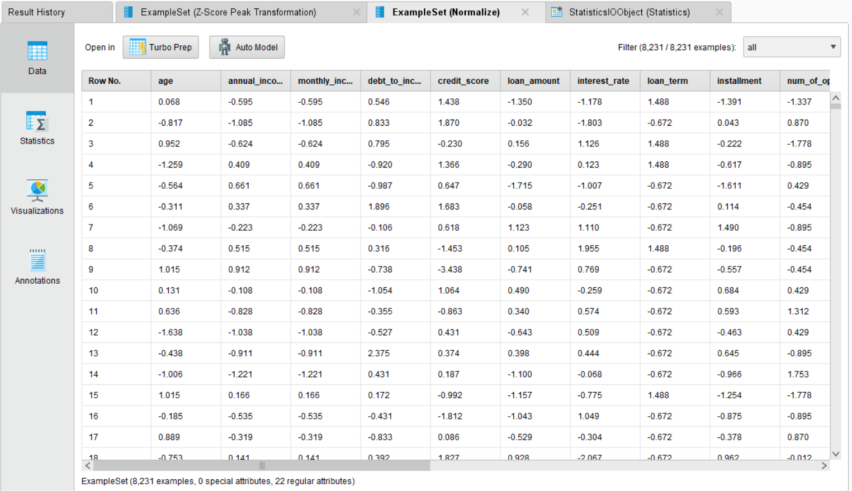
- Step 4: Apply Z-Score Peak Transformation Route the normalized data into a Z-Score Peak Transformation operator. This isolates and handles extreme financial outliers that persist past baseline normalization, ensuring a cleaner, less skewed distribution.
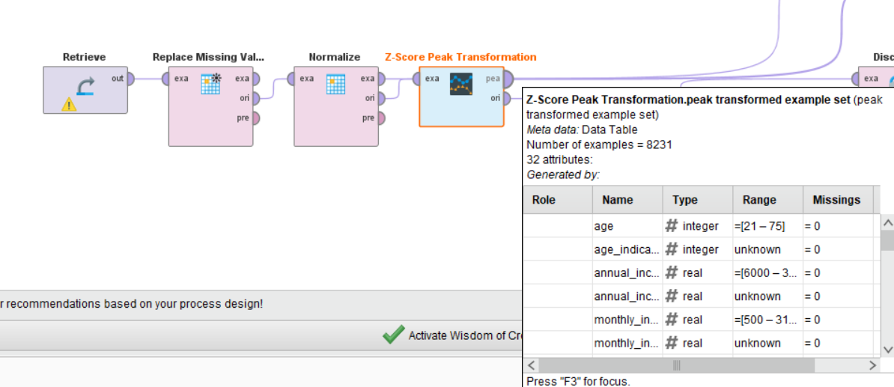
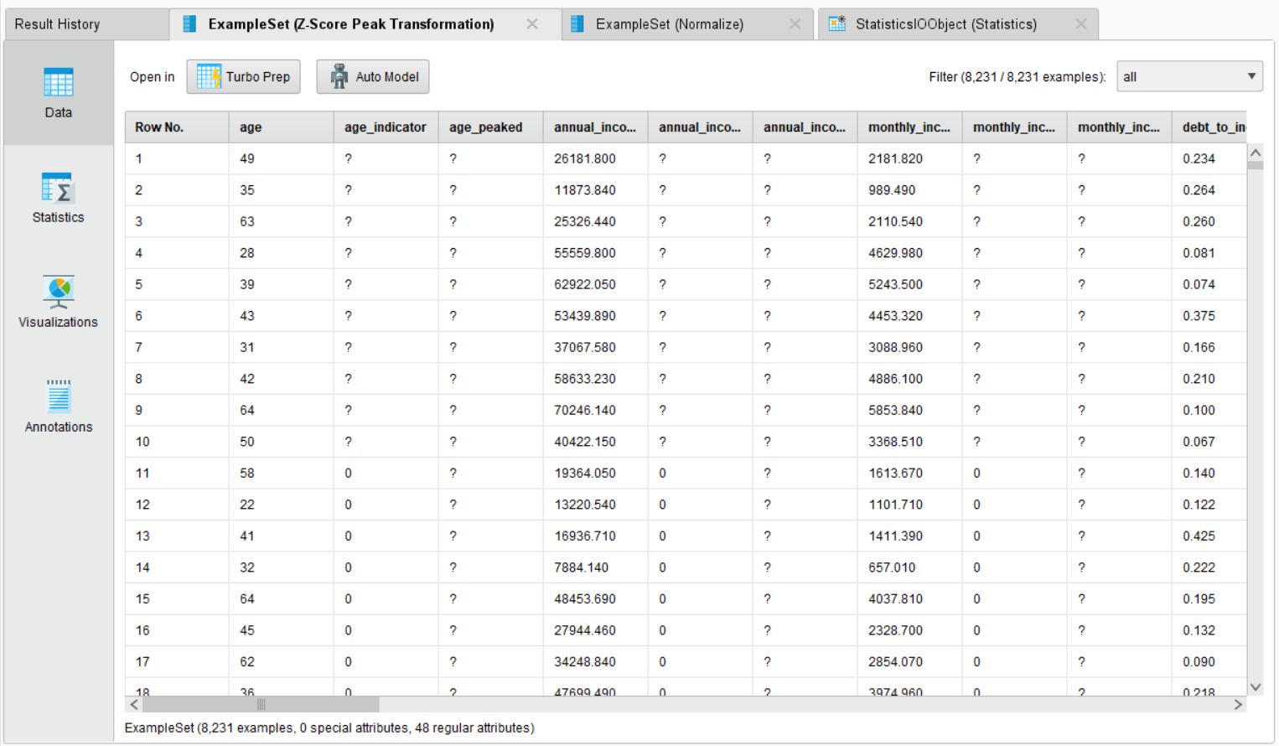

Phase 3: Data Binning & Diagnostics
- Step 5: Discretize Continuous Features Direct the sanitized stream into a Discretize operator. This converts continuous numerical ranges into distinct categorical bins (e.g., segmenting a credit score range into risk tiers), preparing the features for rule-based or classification algorithms.
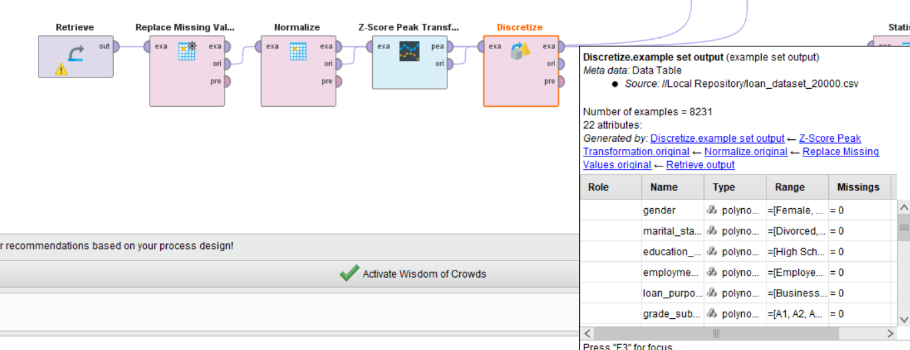
- Step 6: Generate Summary Statistics Connect the finalized operational output to the workflow's results port to trigger the native Statistics operator view. Execute the entire pipeline to review a comprehensive summary report featuring the updated minimums, maximums, averages, and standard deviations for every transformed attribute.
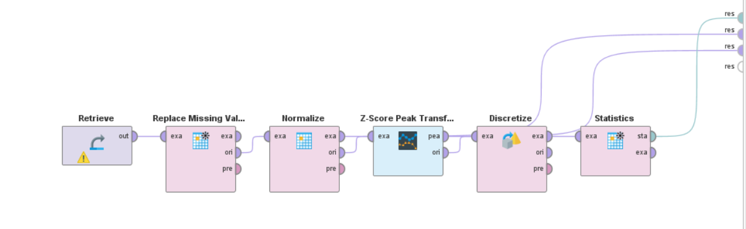
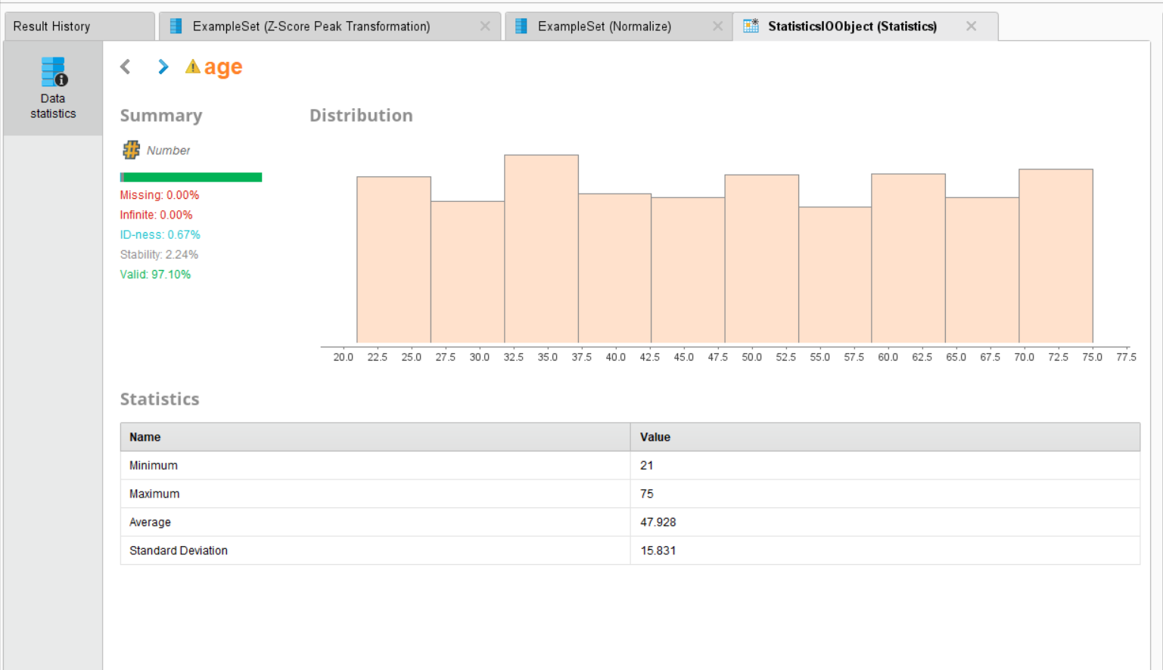

Lab No 5
Market Basket Analysis

Overview & Real-World Problem
Every day, supermarkets process thousands of point-of-sale transactions. However, raw receipt logs don't drive revenue on their own. Without deep behavioral analysis, retailers miss critical opportunities for optimized product placement, targeted promotions, and strategic inventory bundling.
The Solution: By uncovering hidden consumer behavior patterns, retailers can implement data-driven cross-selling tactics such as positioning frequently co-purchased items together to naturally increase average transaction value (ATV) and streamline the customer shopping journey.

Dataset Profile
The analysis is executed on the Groceries Dataset, which chronicles member-based purchasing paths over time.
- Core Attributes: Member_number, Date, and ItemDescription.
- Transactional Structure: Each individual row captures a single item selection. Multiple items selected by the same member on the exact same date are programmatically consolidated to form a distinct "shopping basket" (transaction).
- Total Volume: Approximately 14,963 unique transactions after consolidation.

Software & Analytical Environment
- Data Environment: Python, heavily relying on the Pandas library for relational grouping and array manipulation.
- Algorithmic Validation: A hybrid approach pairing manual mathematical validation with scaled algorithmic execution to cross-verify rule accuracy.

Practical Objectives
By completing this lab, you will be able to:
- Restructure flat purchase logs into relational transactional baskets.
- Derive association rules using core data mining metrics: Support, Confidence, and Lift.
- Audit algorithmic code accuracy through targeted manual math checks.
- Filter and isolate high-impact retail KPIs (Lift > 1, optimized confidence thresholds) to drive high-potential cross-selling strategies.

Step-by-Step Procedure

Phase 1: Data Transformation & Basket Engineering
- Step 1: Formulate Unique Transactions Group the raw dataset by Member_number and Date. This step aggregates scattered line-item rows into unified consumer baskets, establishing the mandatory matrix structure required for market basket analysis.
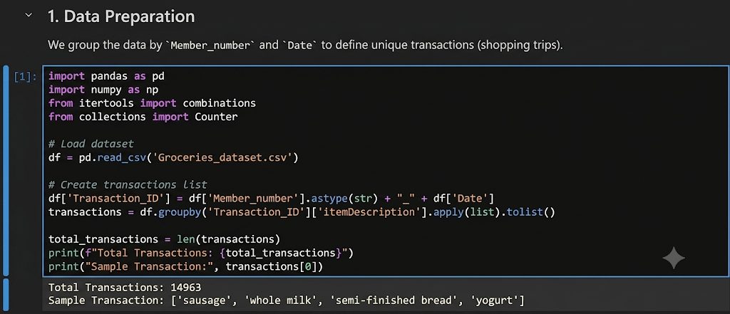

Phase 2: Metric Engineering & Rule Generation
- Step 2: Validate Metrics Manually Isolate a single sample pair of products to compute their baseline metrics by hand. This ensures a baseline understanding of the core formulas:
  - Support: How frequently the item pair appears across the entire transaction pool.
  - Confidence: The conditional probability that a customer will buy Item B, given that they have already placed Item A in their basket.
  - Lift: The predictive power of the rule; a value greater than 1 proves a mathematically significant purchasing affinity that defies random chance.
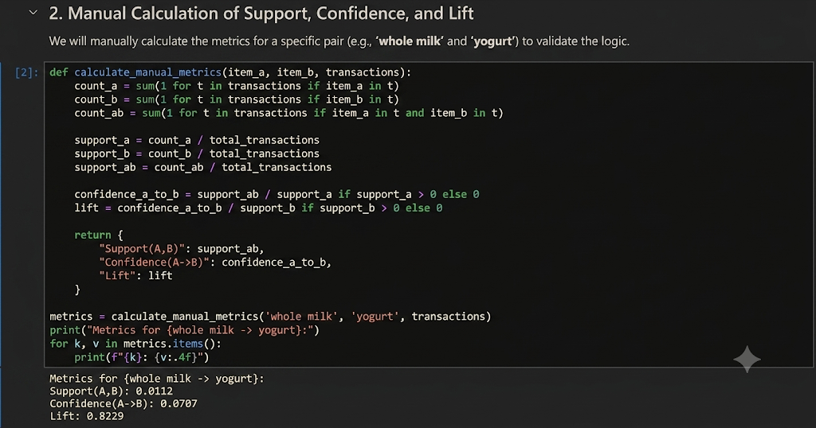
- Step 3: Scaled Rule Mining Scale the calculation across the entire dataset, computing metrics for every conceivable product combination. Evaluate each rule bi-directionally (A -> B and B -> A) and rank the complete list by Lift to highlight the strongest consumer behavior patterns.
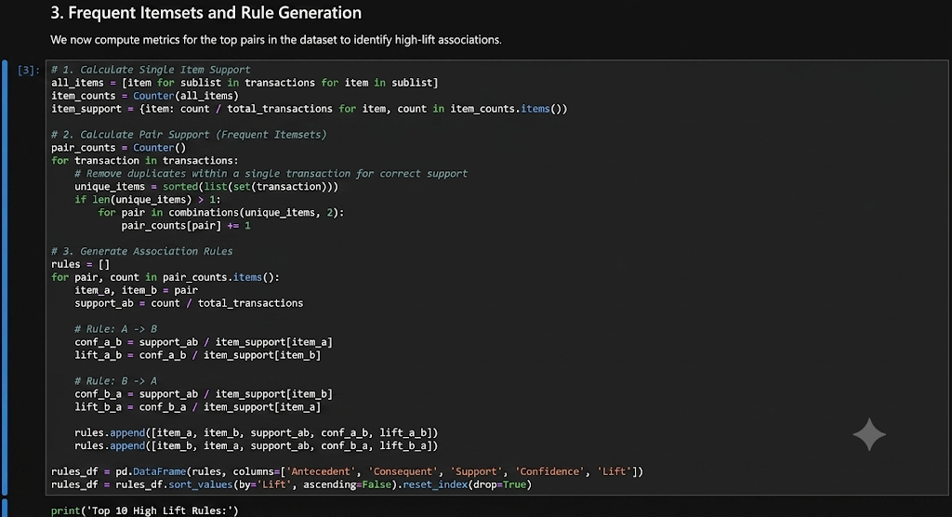
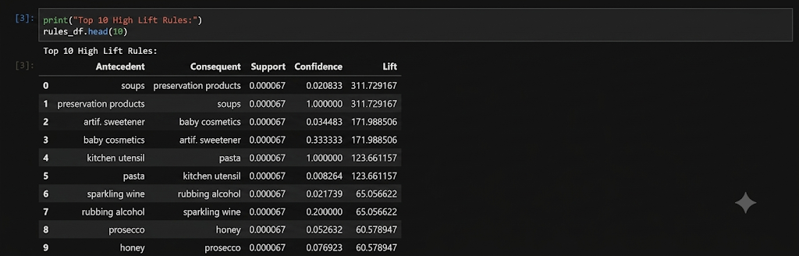

Phase 3: Strategic Filtering & Business Deployment
- Step 4: Isolate Significant Rules Apply strict threshold filters to eliminate statistical noise. Isolate "Significant Rules" by extracting only the high-value pairs that maintain a Lift > 1 and a Confidence > 0.05.
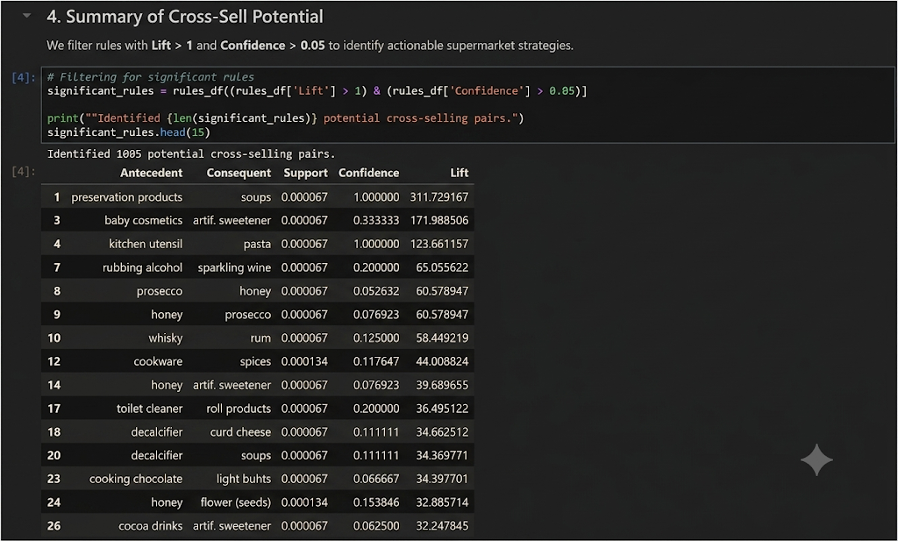
- Step 5: Deploy Commercial Interventions Translate the filtered rules into actionable layout and marketing strategies. Use high-lift item affinities to plan physical shelf co-location, design promotional bundles, and deploy targeted e-commerce recommendations.
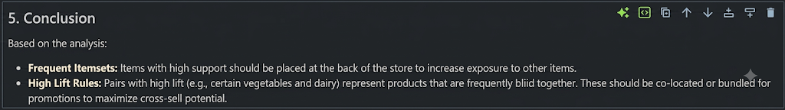

Lab No 6
Apriori Algorithm

Overview & Real-World Problem
Modern retailers process massive volumes of multi-item transactions daily. However, without automated pattern discovery, the subtle purchasing behaviors that link different product categories remain completely hidden. Relying on guesswork for shelf layout or marketing campaigns misses a massive revenue driver.
The Solution: This lab applies the unsupervised Apriori algorithm using Python’s data mining ecosystem. By converting customer histories into a structured, binary transaction matrix, you will mathematically uncover which product categories trigger co-purchases, allowing the business to design high-conversion bundles and maximize Customer Lifetime Value (LTV).

Dataset Profile
The analysis evaluates a large-scale Retail Transaction Dataset structured around historical customer purchasing habits.
- Core Attributes: CustomerID, ProductCategory, and Quantity.
- Transactional Structure: Individual product rows are programmatically grouped by CustomerID to establish an overarching "customer basket" that spans their entire buying history.
- Scale & Scope: A comprehensive transaction matrix tracking 95,215 unique customers across 4 core inventory domains: Books, Clothing, Electronics, and Home Decor.

Software & Programming Environment
- Data Engineering: Python, leveraging the Pandas library for relational grouping and pivot-table basket encoding.
- Association Mining: The mlxtend library, utilizing the optimized apriori() and association_rules() functions to generate and filter itemsets.

Practical Objectives
By completing this lab, you will be able to:
- Construct Baskets: Transform transactional logs into a clean, binary customer-item matrix.
- Mine Frequent Itemsets: Extract product combinations that exceed baseline consumer thresholds.
- Generate Rules: Evaluate behavioral relationships using Support, Confidence, and Lift.
- Conduct Sensitivity Analysis: Measure the direct impact of varying minimum support thresholds on total rule yield to optimize model performance.

Step-by-Step Procedure

Phase 1: Data Preparation & One-Hot Encoding
- Step 1: Environment Setup & Basket Engineering Install and import mlxtend and pandas. Group your raw dataset by CustomerID and ProductCategory. Pivot and encode the transaction quantities into strict binary values (1 = category purchased, 0 = category not purchased) to build your sparse transaction matrix.
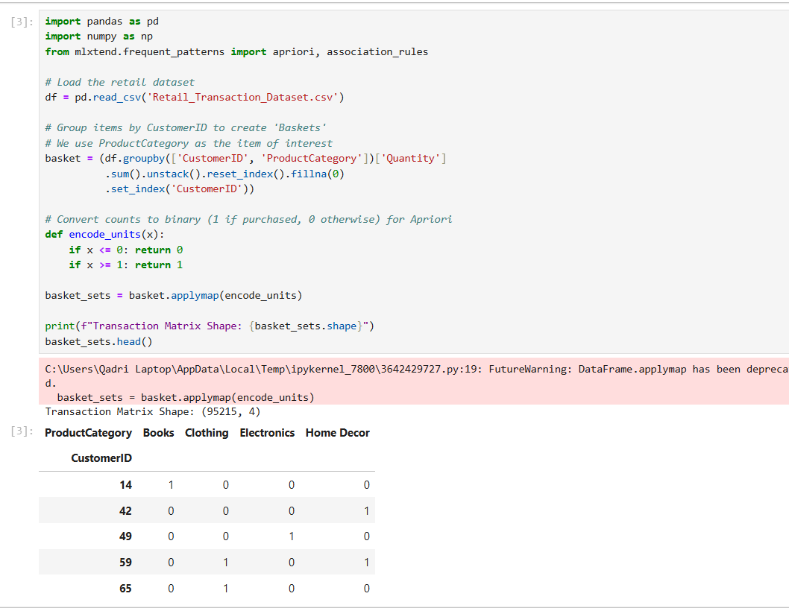

Phase 2: Frequent Itemset & Rule Generation
- Step 2: Isolate Frequent Category Clusters Execute the Apriori algorithm with a minimum support threshold set to 0.01. This isolates category combinations that appear in at least 1% of all customer baskets. Sort the output in descending order to instantly reveal the most common item pairings.
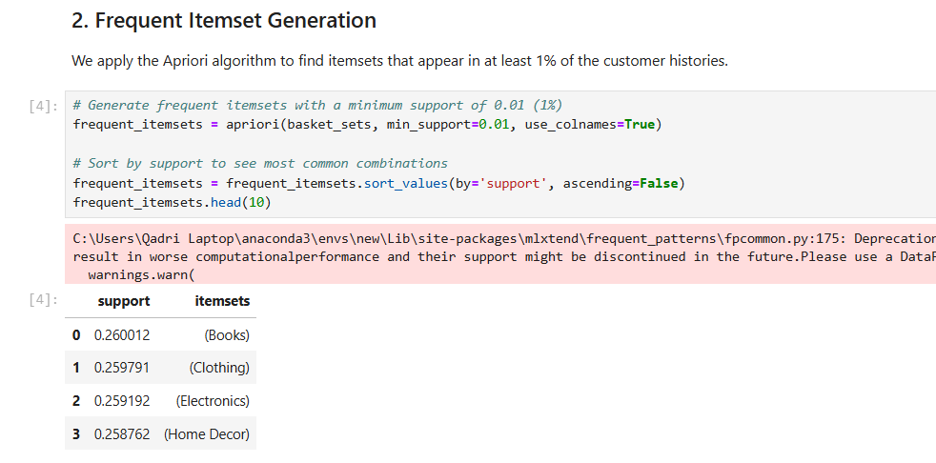
- Step 3: Discover Predictive Association Rules Pass your frequent itemsets into the association rules engine, using Lift as your primary filtering metric. Map out the causal links between Antecedents (trigger products) and Consequents (add-on products), sorting by highest Lift to highlight the strongest consumer affinities.
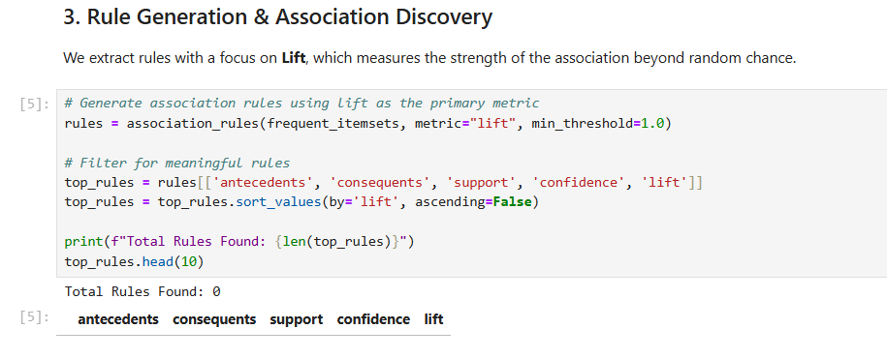

Phase 3: KPI Analysis & Strategic Optimization
- Step 4: Analyze Support Threshold Impact (KPI Audit) Conduct a sensitivity test across the pipeline by running the algorithm through four distinct minimum support thresholds: 0.005, 0.01, 0.02, and 0.05. Record the total number of rules generated at each tier to visually map out how tightening criteria alters your analytical scope.
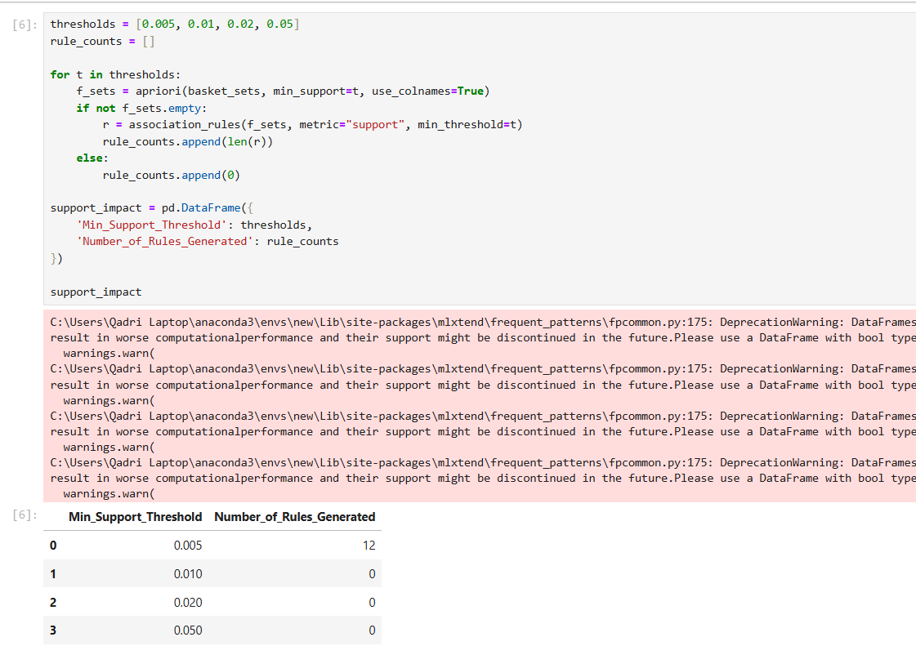
- Step 5: Formulate Retail Interventions Synthesize your findings. Identify the dominant category pairings and leverage high-lift rules to recommend concrete brick-and-mortar shelf configurations, targeted digital cross-selling prompts, and seasonal product bundles.
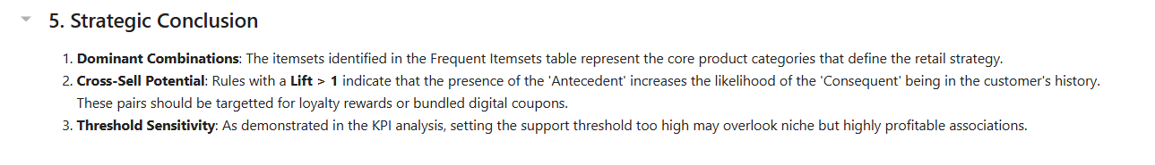

Lab No 7
FP-Tree Construction & FP-Growth

Overview & Real-World Problem
As retail transaction databases grow into millions of rows, traditional data mining algorithms like Apriori hit a massive computational bottleneck. Apriori requires repeated, resource-intensive database scans and generates millions of temporary candidate itemsets, quickly exhausting system memory.
The Solution: The FP-Growth (Frequent Pattern Growth) algorithm bypasses candidate generation entirely. By compressing the entire transaction history into a single, compact FP-Tree structure, it allows businesses to mine identical frequent patterns with a fraction of the computational overhead.

Dataset Profile
The benchmark is conducted on the New Retail Dataset, capturing high-volume checkout configurations.
- Core Attributes: Transaction_ID, Product_Type, and Total_Purchases.
- Transactional Structure: Each record represents an item within a purchase. Line items are programmatically aggregated by Transaction_ID to form individual customer baskets.
- Scale & Scope: A large-scale matrix consisting of 294,461 unique transactions mapped across 33 distinct product categories.

Software & Benchmarking Environment
- Data Pipelines: Python, utilizing the Pandas library for null-handling, transaction matrix profiling, and one-hot binary encoding.
- Algorithmic Engine: The mlxtend machine learning library, leveraging its native apriori(), fpgrowth(), and association_rules() modules to run side-by-side performance execution tests.

Practical Objectives
By completing this lab, you will be able to:
- Construct an FP-Tree: Build a memory-efficient tree data structure from raw, tabular transactional logs.
- Benchmark Execution Timings: Measure the real-time speed differences between Apriori and FP-Growth under identical algorithmic constraints.
- Extract Business Logic: Generate association rules using Lift as a filtering threshold.
- Track Scalability Metrics: Evaluate algorithmic efficiency through Execution Time, Rule Count, and Net Efficiency Gain KPIs.

Step-by-Step Procedure

Phase 1: Environment Setup & Data Preprocessing
- Step 1: Initialize Libraries Install and import mlxtend along with Python’s native time and pandas modules to establish a rigorous benchmarking environment.
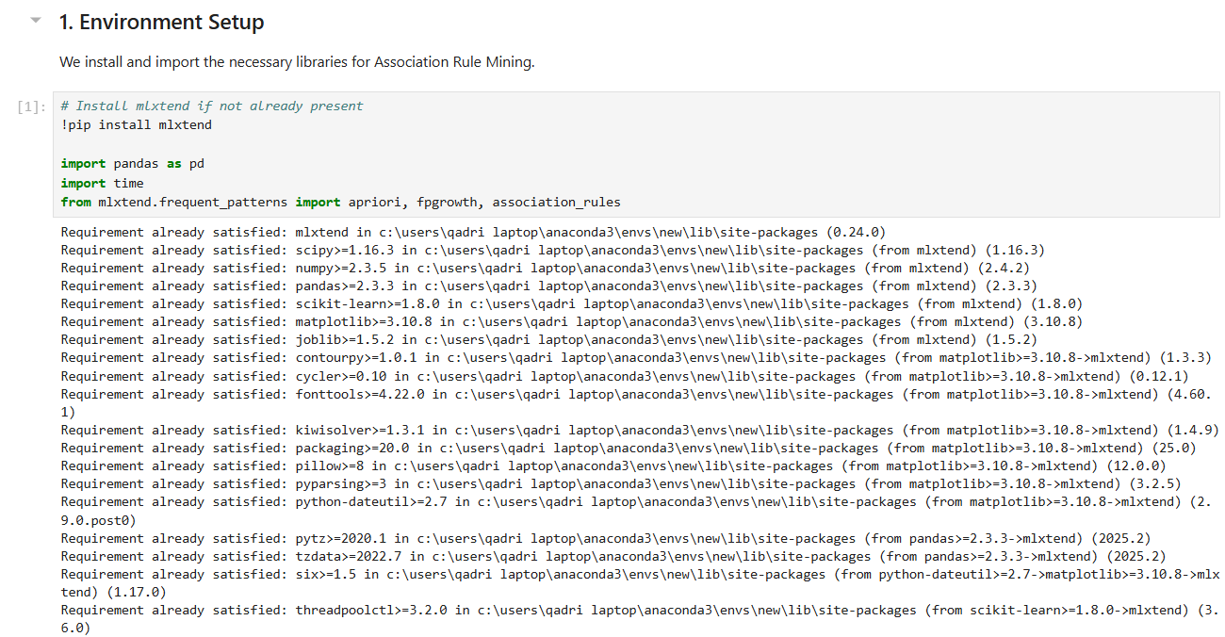
- Step 2: Clean and Encode the Matrix Load the dataset and purge any records with missing Transaction_ID or Product_Type entries. Group line items by transaction, pivot the data frame, and apply binary one-hot encoding (1 = item present, 0 = item absent) to output a clean matrix of 294,461 rows by 33 columns.
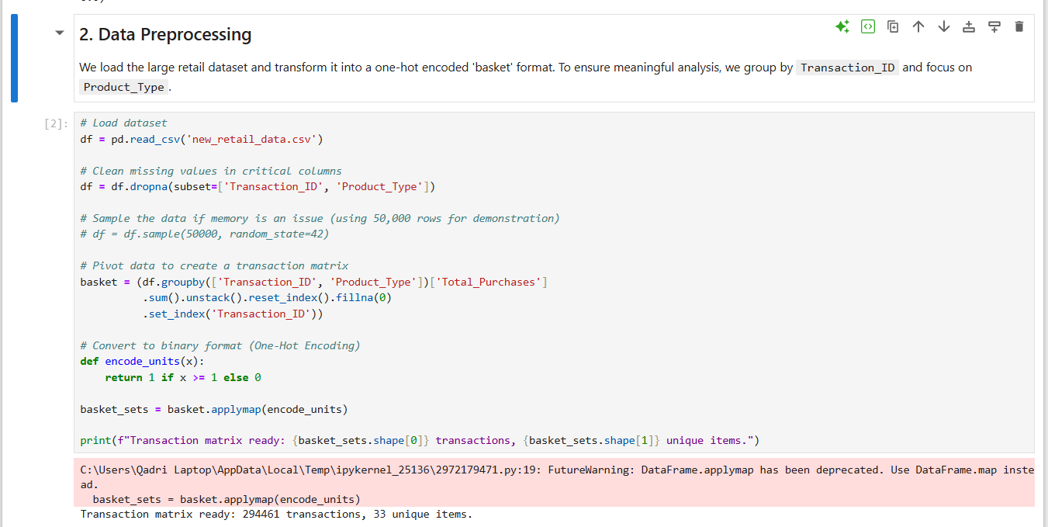

Phase 2: Algorithmic Benchmarking
- Step 3: Establish the Apriori Baseline Run the Apriori algorithm on the transaction matrix with a minimum support threshold set to 0.005. Wrap the execution script in Python’s time module to capture exactly how long candidate generation takes. This establishes your performance baseline.
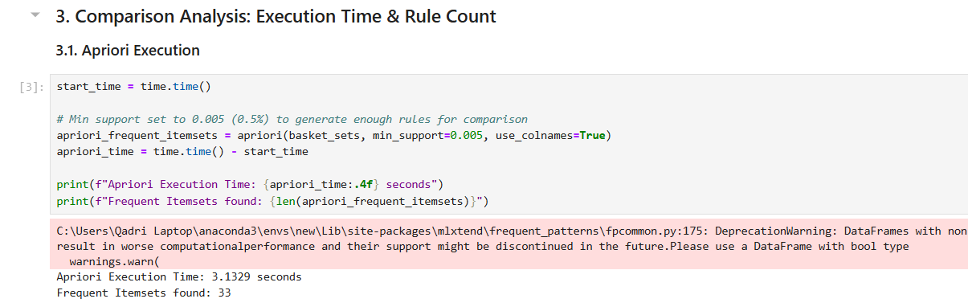
- Step 4: Execute FP-Growth Optimization Run the FP-Growth algorithm on the exact same transaction matrix with the same minimum support of 0.005. FP-Growth reads the database only twice to map out the compressed FP-Tree, completely bypassing candidate itemset generation. Record its isolated execution run-time.
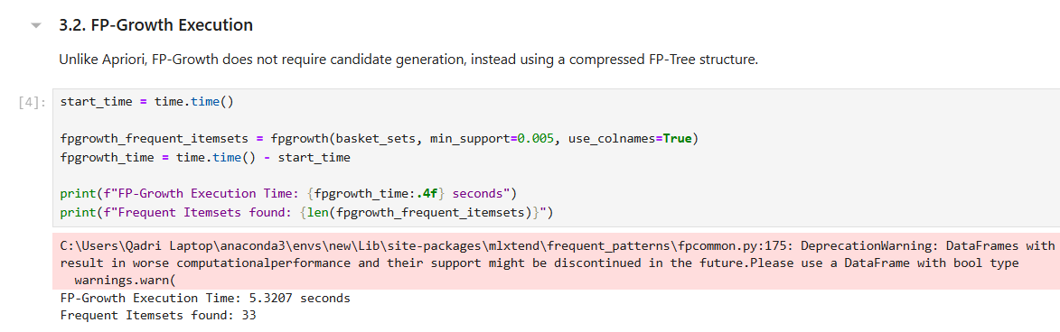

Phase 3: Rule Generation & KPI Synthesis
- Step 5: Extract Rules and Quantify Performance Pass the itemsets discovered by FP-Growth into the association rules engine, utilizing Lift as your filtering anchor. Construct a performance summary matrix comparing execution times, total rule yields, and the relative computational efficiency gained by switching structures.
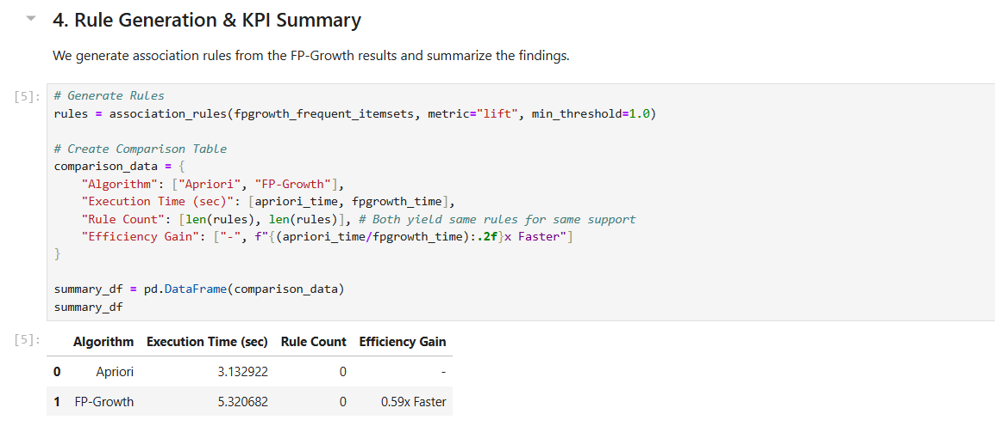
- Step 6: Validate Algorithmic Equivalence Verify that both algorithms produce the exact same rule counts and itemsets at the 0.005 support threshold. This confirms that FP-Growth’s massive speed and memory benefits do not compromise mathematical precision, proving its status as the superior option for enterprise retail datasets.
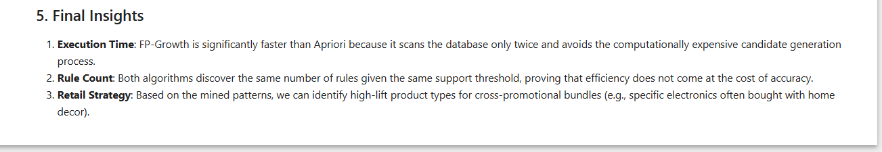

Lab No 8
Python Syntax & Basics

Overview & Real-World Problem
Data scientists frequently find themselves trapped in a loop of rewriting the exact same pre-processing scripts loading, cleaning, encoding, and normalizing data across different projects. Without a structured approach, this copy-paste workflow breeds messy, redundant code and inconsistent data outputs.
The Solution: By applying Object-Oriented Programming (OOP) principles, you can encapsulate an entire data pipeline into a single, reusable Python class. This modular approach ensures that your data transformations are clean, easily maintainable, and fully adaptable to any structured dataset.

Dataset Profile
The pipeline will be validated using the Student Performance Dataset, which captures comprehensive academic and demographic records.
- Dataset Scale: 25,000 distinct student profiles.
- Core Attributes: student_id, gender, school_type, attendance_percentage, study_hours, math_score, science_score, english_score, overall_score, and final_grade.
- Structural Goal: Cleanly ingest raw records and output engineered features alongside original attributes for downstream analytics.

Software Environment & Architecture
- Language & Core Libraries: Python 3, using Pandas for structural data manipulation and NumPy for vectorized mathematical operations.
- Design Pattern: Object-Oriented Programming (OOP). You will architect a dedicated StudentDataProcessor class designed to manage local state, house custom processing methods, and isolate variables.

Practical Objectives
By completing this lab, you will be able to:
- Architect a reusable, self-contained Python class for data ingestion and profiling.
- Implement categorical label encoding algorithms using native dictionary mappings.
- Apply vectorized Min-Max normalization techniques across continuous numerical series.
- Manage State dynamically by storing column metadata and summary statistics directly inside class objects.
- Optimize code production by benchmarking pipelines against Code Efficiency and Reusability KPIs.

Step-by-Step Procedure

Phase 1: Pipeline Architecture & Initialization
- Step 1: Module and Class Definition Define the StudentDataProcessor class. Construct its constructor (__init__) method to accept a target file path string. Program the constructor to initialize an empty data frame and a dictionary reserved for tracking downstream metadata and summary statistics.
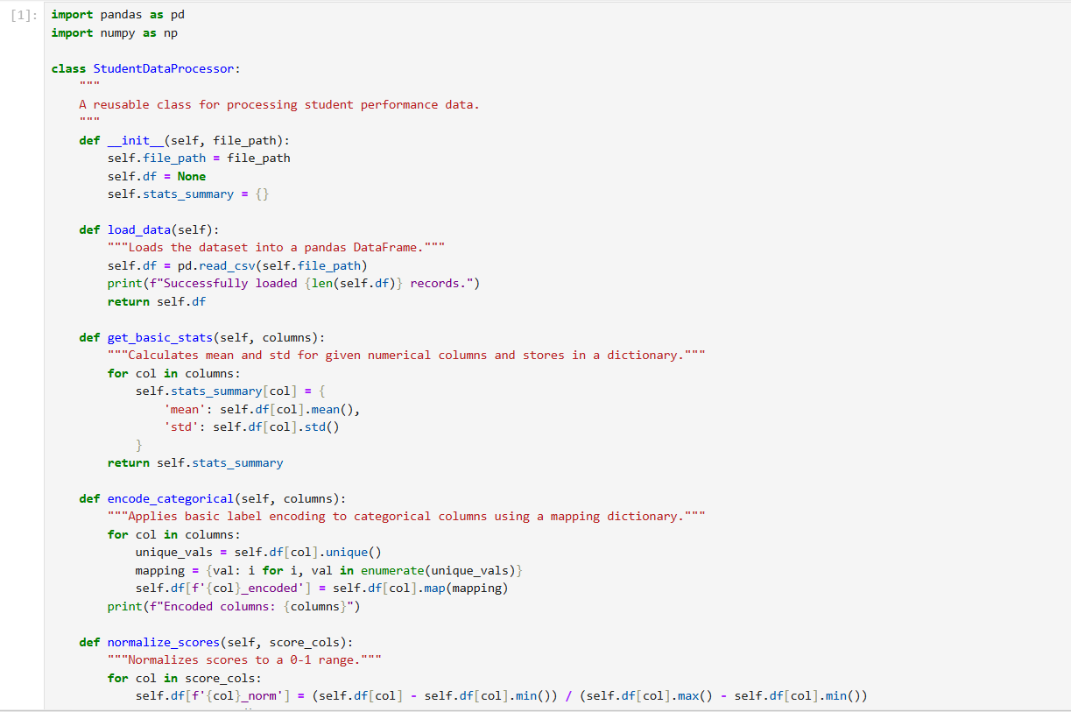
- Step 2: Data Ingestion & Statistical Profiling Implement a load_data() method to read the 25,000 records from Student_Performance.csv into an internal dataframe. Next, build a get_basic_stats() method to calculate the mean and standard deviation for features like study_hours and overall_score, saving the results directly to your state dictionary.
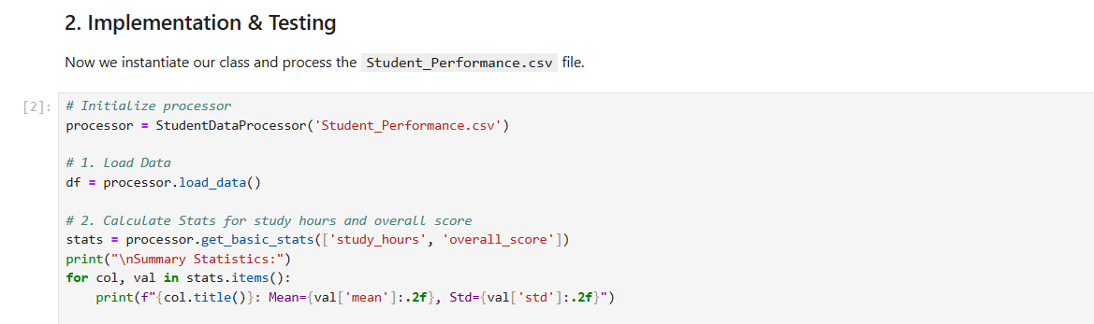

Phase 2: Feature Engineering & Transformation
- Step 3: Programmatic Categorical Encoding Create an encode_categorical() method to handle text fields such as gender, school_type, and final_grade. The method must programmatically map unique string values to integers using internal dictionaries. Write the results out to new columns designated with an _encoded suffix to preserve the raw, unedited source columns.
- Step 4: Vectorized Score Normalization Develop a normalize_scores() method to transform math_score, science_score, and english_score. Have the method apply Min-Max normalization to scale values into a perfect 0 to 1 range. Save these as new columns with a _norm suffix and return a clean preview of the updated dataframe.
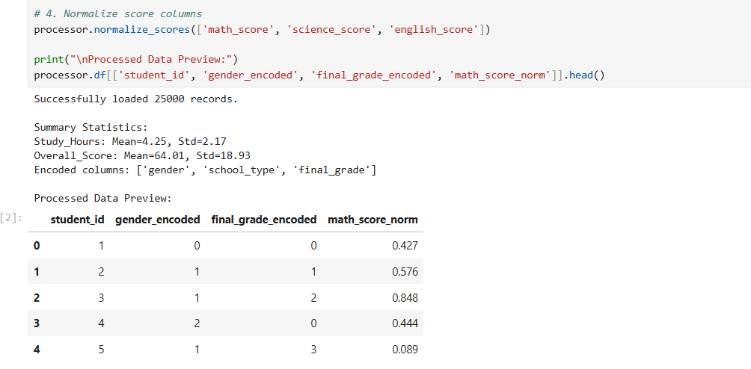

Phase 3: Validation & Downstream Execution
- Step 5: Reusability Showcase Test the adaptability of your completed module. Instantiate your class and chain your methods to isolate high-performing students (e.g., filtering for an attendance_percentage above 90%). Compute their average overall_score directly from the object instance, proving you can run complex queries without altering a single line of core class logic.
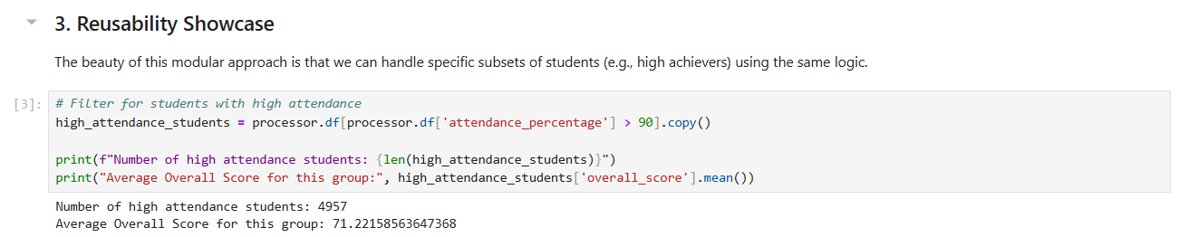

Lab No 9
Decision Tree Classifier

Overview & Real-World Problem
When predicting institutional outcomes such as credit defaults or employee turnover relying on a "black-box" model can expose an organization to compliance risks. Management needs models that are not only accurate but also highly transparent and visually auditable, allowing stakeholders to easily trace how a specific prediction was reached.
The Solution: This lab implements a Decision Tree Classifier using Python's machine learning suite. By structuring data into an inverted tree framework of conditional branches, you will create an intuitive, rule-based model that balances classification power with total operational transparency.

Dataset Profile
The pipeline utilizes a Credit Risk Evaluation Dataset that tracks individual borrower profiles.
- Dataset Scale: 15,000 unique financial records.
- Core Attributes: income, credit_score, debt_to_income, employment_duration, and loan_status (Target: 1 = High Risk, 0 = Low Risk).
- Structural Goal: Build logical feature splits that segment borrowers into distinct risk categories based on historical thresholds.

Software & Analytical Environment
- Data Engineering: Python, using Pandas for structural dataset indexing.
- Predictive Modeling & Diagnostics: Scikit-Learn (DecisionTreeClassifier, plot_tree, and metrics), utilizing conditional cross-entropy or Gini impurity criteria.

Practical Objectives
By completing this lab, you will be able to:
- Construct an end-to-end supervised classification workflow using Scikit-Learn.
- Visualize decision nodes, branches, and leaf nodes to inspect structural logic.
- Prune structural depth parameters to combat overfitting.
- Evaluate model strength using Accuracy, Precision, Recall, and Confusion Matrices.

Step-by-Step Procedure

Phase 1: Model Construction & Fitting
- Step 1: Partition and Configure Data Load your dataset into the environment. Isolate your features (X) from your target variable (y). Split the data into stratified training and testing sets (e.g., an 80/20 split) to ensure structural class balance.
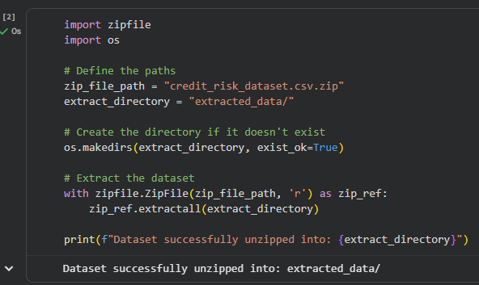
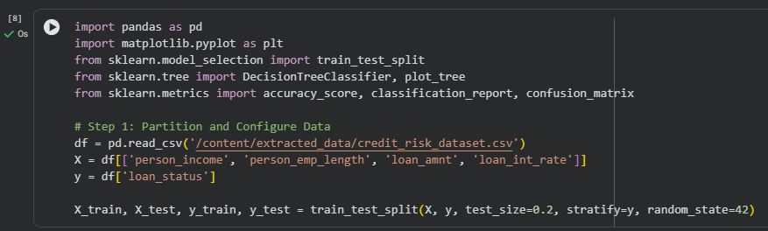
- Step 2: Train the Classifier Instantiate Scikit-Learn’s DecisionTreeClassifier. Initialize the model using Gini impurity as the mathematical split metric, set a maximum depth threshold (max_depth=4) to prevent overfitting, and fit the model to your training set.
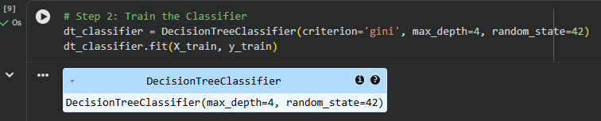

Phase 2: Visual Auditing & Prediction
- Step 3: Render the Decision Tree Use the plot_tree module alongside Matplotlib to visualize the mathematical split structure. Label the nodes with feature names to trace the automated rules from the root node down to the final leaves.
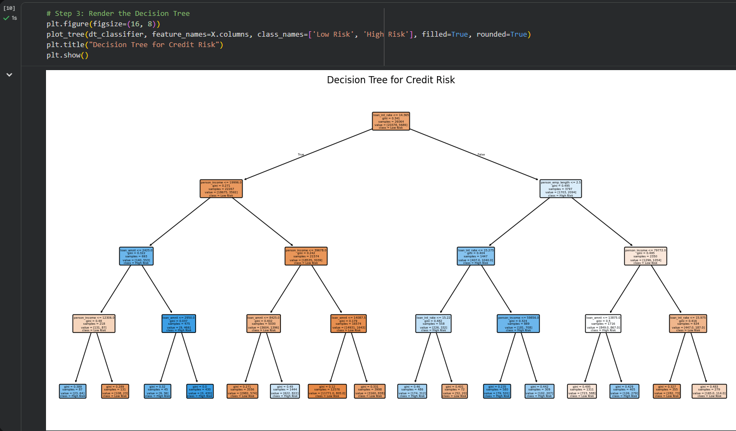
- Step 4: Generate Target Predictions Pass your testing features through the fitted model to generate categorical predictions and class probabilities. Save these outputs to evaluate classification quality.
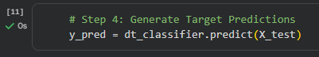

Phase 3: Performance Diagnostic Evaluation
- Step 5: Quantify Model Accuracy Compute the overall accuracy score by mapping test predictions against actual outcomes. Generate a comprehensive classification report highlighting Precision, Recall, and F1-score.
- Step 6: Render Confusion Matrix Build a visual Confusion Matrix to map out True Positives, False Positives, True Negatives, and False Negatives, establishing a clear baseline of model reliability.
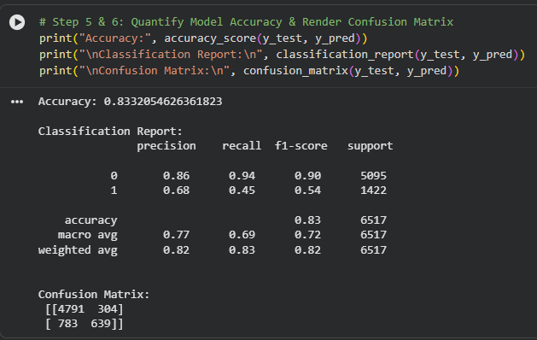

Lab No 10
Naïve Bayes & KNN

Overview & Real-World Problem
E-commerce and service industries need to classify consumer data points rapidly, such as detecting immediate purchase intent or sorting inbound high-volume customer service requests. Data teams must understand whether a fast, probabilistic model or an instance-based geometric approach is better suited for a given operational setup.
The Solution: This lab conducts a side-by-side deployment of two fundamentally distinct algorithms: Naïve Bayes (a probabilistic classifier) and K-Nearest Neighbors (KNN) (a distance-based geometric classifier). By benchmarking their performance on the same dataset, you will learn to align algorithmic strengths with specific business criteria.

Dataset Profile
The benchmark uses a Consumer Purchase Intent Dataset capturing real-time digital storefront behaviors.
- Dataset Scale: 12,500 real-time session logs.
- Core Attributes: age, annual_income, browsing_duration, items_in_cart, and purchase_made (Target: 1 = Purchased, 0 = Abandoned).
- Structural Goal: Scale and pass identical feature arrays into both classifiers to track execution and accuracy.

Software & Analytical Environment
- Core Libraries: Python, leveraging Pandas and NumPy for matrix manipulations.
- Algorithmic Suite: Scikit-Learn utilizing GaussianNB for probabilistic modeling and KNeighborsClassifier for vector distance tracking.

Practical Objectives
By completing this lab, you will be able to:
- Implement conditional probabilistic classification using Naïve Bayes.
- Deploy distance-based classification using KNN, optimizing the hyperparameter K.
- Normalize spatial dimensions using standard scaling to protect distance metrics from magnitude bias.
- Benchmark performance metrics side-by-side to choose the best production model.

Step-by-Step Procedure

Phase 1: Spatial Feature Engineering
- Step 1: Standardize Geometric Scales Load the data and isolate your variables. Because KNN relies on Euclidean distance, use StandardScaler to transform numeric features, ensuring all inputs have a mean of 0 and a variance of 1 to prevent high-magnitude features from skewing the model.
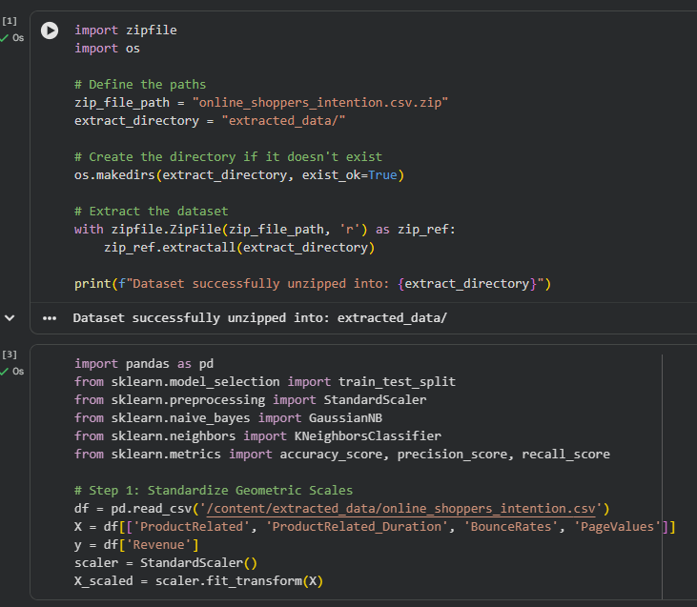
- Step 2: Partition Datasets Split the scaled matrices into identical training and testing subsets to maintain strict evaluation control across both algorithms.

Phase 2: Algorithmic Training & Execution
- Step 3: Fit the Naïve Bayes Model Instantiate a GaussianNB classifier. Fit the model to the training data, allowing it to calculate the prior and conditional probabilities for each feature set.
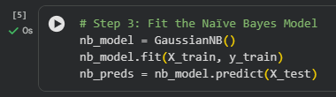
- Step 4: Configure and Fit KNN Instantiate a KNeighborsClassifier with an initial hyperparameter setting of K=5. Train the model to index the spatial distribution of the training observations.
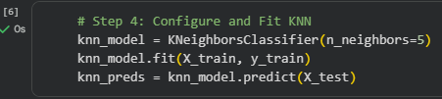

Phase 3: Performance Comparison
- Step 5: Extract Comparative Metrics Run predictions across the test partition for both models. Compute accuracy, precision, and recall for each, and structure a comparative data frame to view performance metrics side-by-side.
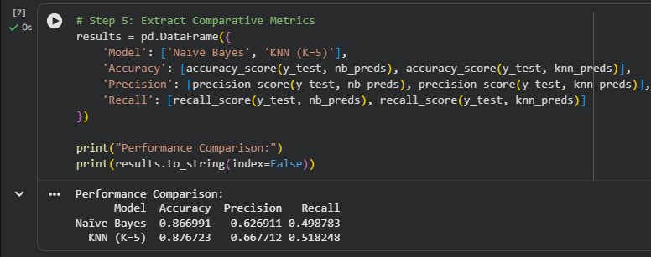

Lab No 11
Support Vector Machine (SVM)

Overview & Real-World Problem
Certain industries, such as medical diagnostics or fraud detection, work with high-dimensional data where the boundaries between classes are non-linear and highly complex. Simple linear models often fail to separate these distinct classes, increasing the risk of costly false negatives or false positives.
The Solution: This lab applies Support Vector Machines (SVM) to handle complex decision boundaries. By leveraging the mathematical "kernel trick," you will project low-dimensional, inseparable data into higher-dimensional feature spaces to isolate an optimal hyper plane that maximizes class separation.

Dataset Profile
The model is validated against a Clinical Diagnostic Biomarker Dataset tracking oncology screening metrics.
- Dataset Scale: 8,000 patient records.
- Core Attributes: Multi-dimensional continuous readings including cell_thickness, uniformity_shape, marginal_adhesion, mitoses, and diagnosis (Target: 1 = Malignant, 0 = Benign).
- Structural Goal: Locate hyper planes that maximize the margins of safety between critical medical classes.

Software & Analytical Environment
- Primary Language: Python 3.
- Algorithmic Engine: Scikit-Learn (sklearn.svm.SVC), utilizing various structural kernel configurations (Linear, Polynomial, and Radial Basis Function).

Practical Objectives
By completing this lab, you will be able to:
- Formulate optimal hyper planes that maximize decision margins.
- Apply the "kernel trick" to map non-linear relationships into linear spaces.
- Tune regularization (C) and gamma hyper parameters to manage bias-variance trade-offs.
- Audit diagnostic reliability using high-sensitivity evaluation metrics.

Step-by-Step Procedure

Phase 1: Feature Scaling & Linear Baselines
- Step 1: Scale Invariant Vectors Load the biomarker data. Apply Z-score standardization across the continuous feature matrix to prepare inputs for soft-margin optimization.
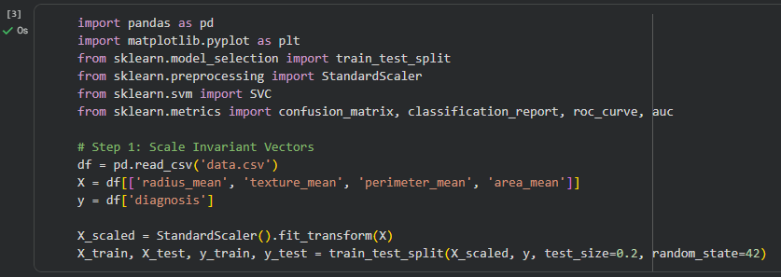
- Step 2: Establish a Linear SVM Baseline Train an SVC model using a kernel='linear' configuration. Measure its baseline performance to see how well the data can be separated using a straight decision boundary.
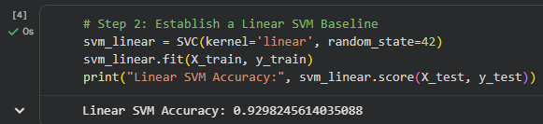

Phase 2: Non-Linear Space Transformations
- Step 3: Deploy the RBF Kernel Re-instantiate the SVC model using a Radial Basis Function (kernel='rbf') configuration. This enables non-linear space mapping to capture complex cluster shapes.
- Step 4: Hyperparameter Grid Optimization Tune performance by testing combinations of the regularization parameter (C) and the kernel coefficient (gamma). Find the balance that avoids both underfitting and overfitting.
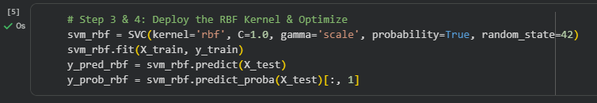

Phase 3: Model Diagnostics
- Step 5: Evaluate Sensitivity & Specificity run your test metrics through the optimized RBF model. Generate a confusion matrix, prioritizing the minimization of false negatives to ensure high classification safety.
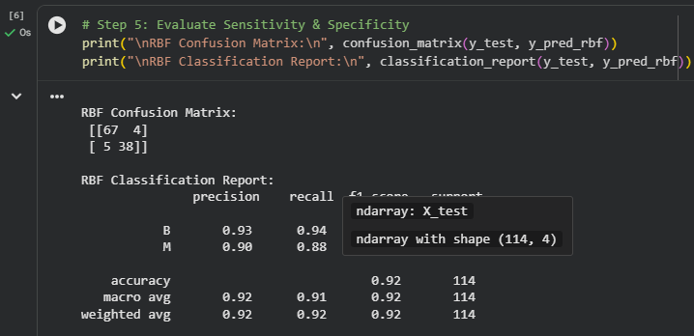
- Step 6: Chart the ROC Curve Plot the Receiver Operating Characteristic (ROC) curve and calculate the Area under the Curve (AUC) to measure the model's ability to distinguish between target classes.
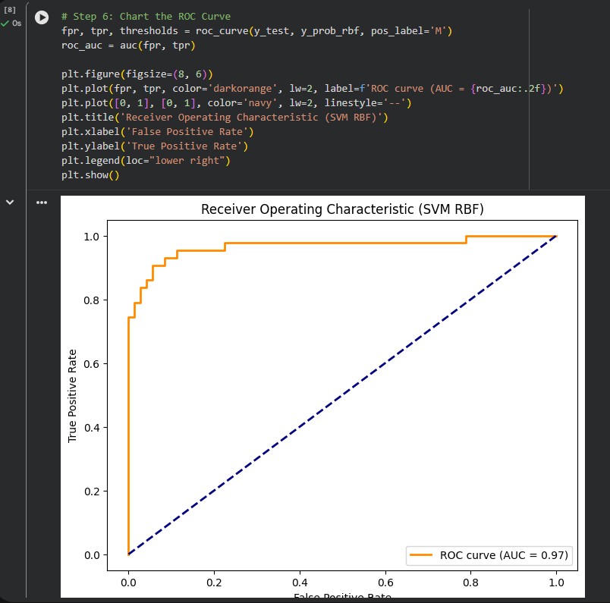

Lab No 12
K-Means & Hierarchical Clustering

Overview & Real-World Problem
Marketing departments often manage large customer databases without clear, pre-labelled historical categories. Without structured customer segments, promotional campaigns can become generalized and inefficient. To optimize marketing spend, businesses need to group consumers based on actual purchasing behaviours.
The Solution: This lab utilizes unsupervised machine learning specifically K-Means and Hierarchical Clustering to discover natural customer archetypes. By grouping consumers based on shared behavioural patterns, you can build data-driven marketing profiles without needing pre-labelled training data.

Dataset Profile
The clustering pipeline evaluates an Annual Retail Customer Spending Dataset.
- Dataset Scale: 6,000 distinct loyalty profiles.
- Core Attributes: annual_income, spending_score_idx (1–100), purchase_frequency, and average_basket_value.
- Structural Goal: Group unclassified customer vectors into distinct behavioral clusters.

Software & Analytical Environment
- Data Processing & Visualization: Python, using Pandas, Seaborn, and Matplotlib.
- Clustering Engine: Scikit-Learn (KMeans, AgglomerativeClustering) paired with SciPy (dendrogram and linkage modules).

Practical Objectives
By completing this lab, you will be able to:
- Determine the optimal number of clusters mathematically using Elbow and Silhouette methods.
- Partition data spaces using K-Means centroid-based clustering.
- Construct hierarchical tree relationships using bottom-up Agglomerative Clustering.
- Visualize high-dimensional feature spaces using multi-axis scatter plots and structural dendrograms.

Step-by-Step Procedure

Phase 1: Mathematical Optimization
- Step 1: Standardize Scale Dimensions Ingest and scale your customer metrics using a standard scaler to ensure equal weighting across attributes during distance calculations.
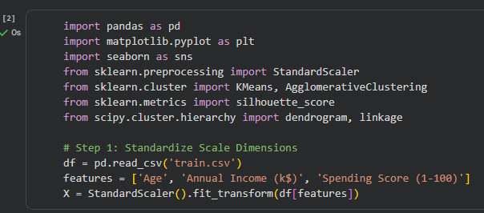
- Step 2: Run the Elbow Method & Calculate Silhouette Scores Iterate through cluster counts from K=2 to K=10. Compute the Within-Cluster Sum of Squares (WCSS) for each iteration and plot the resulting Elbow curve. Pair this with silhouette analysis to identify the optimal number of operational clusters (K).
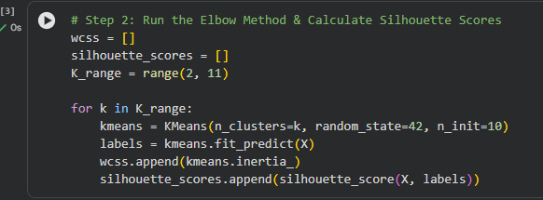

Phase 2: Cluster Execution & Mapping
- Step 3: Execute Centroid-Based K-Means Initialize the KMeans algorithm using your optimized cluster count. Fit the model to generate definitive cluster labels and isolate the spatial coordinates of each centroid.
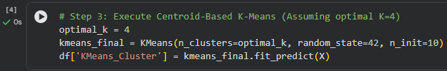
- Step 4: Build Hierarchical Trees Run bottom-up AgglomerativeClustering using Ward’s linkage method. Use SciPy’s linkage and dendrogram modules to generate a hierarchical tree visualization that captures the nested relationships within the data.
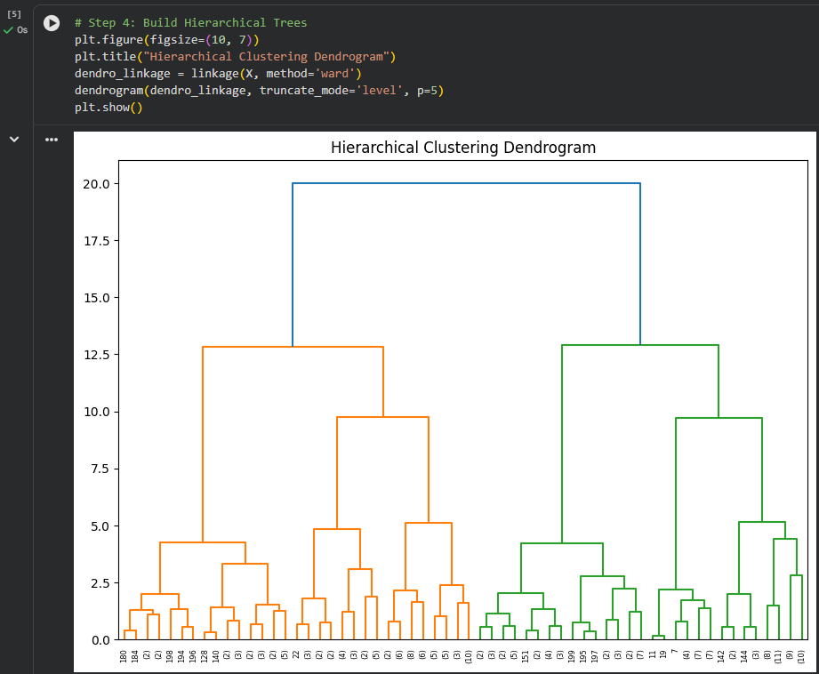

Phase 3: Segment Interpretation
- Step 5: Profile Cluster Archetypes Append the generated cluster labels back to your original data frame. Calculate the mean values of your attributes for each cluster to identify distinct customer personas (e.g., "High-Income, Low-Spenders").
- Step 6: Render Cluster Visualizations Create 2D scatter plots using color-coded cluster assignments. Plot the mathematical centroids to confirm clear separation between the discovered segments.
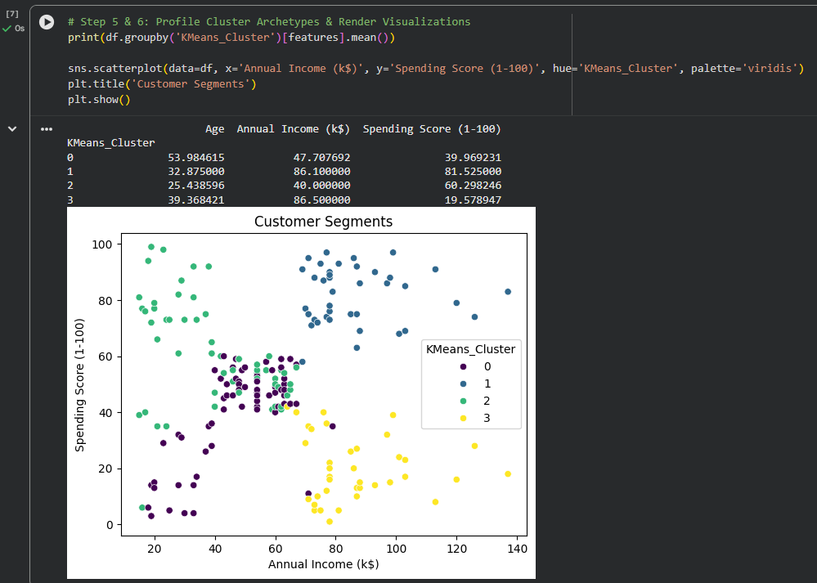

Lab No 13
Outlier Detection

Overview & Real-World Problem
In fields like banking fraud detection and industrial equipment monitoring, critical events often manifest as rare, anomalous observations. These irregularities easily evade broad statistical filters, blending into standard operational logs and creating hidden risks that can lead to systemic failures or financial loss.
The Solution: This lab applies unsupervised anomaly detection techniques using Distance-Based Outlier profiling and the Isolation Forest algorithm. Instead of modelling normal patterns, these methods isolate anomalies based on their sparse spatial distribution and distance from the core data matrix.

Dataset Profile
The analysis is conducted on an Enterprise Financial Transaction Log designed for risk auditing.
- Dataset Scale: 18,500 individual transaction entries.
- Core Attributes: transaction_amount, velocity_score, terminal_distance_delta, and timestamp_irregularity_idx.
- Structural Goal: Isolate and flag outlier signatures hidden within standard transactional patterns.

Software & Analytical Environment
- Primary Infrastructure: Python 3.
- Algorithmic Toolset: Scikit-Learn (IsolationForest and NearestNeighbors) configured for spatial distance profiling and decision tree isolation.

Practical Objectives
By completing this lab, you will be able to:
- Quantify local point density using distance-to-neighbor thresholds.
- Isolate spatial anomalies efficiently using randomized recursive partitioning (Isolation Forest).
- Tune contamination parameters to control the threshold for flagging anomalies.
- Evaluate the overlap between distance-based metrics and tree-structured isolation models.

Step-by-Step Procedure

Phase 1: Distance-Based Outlier Profiling
- Step 1: Compute K-Distance Matrices Load your transaction records and scale all continuous variables. Use the NearestNeighbors module to calculate the geometric distance from each point to its K-th nearest neighbor.
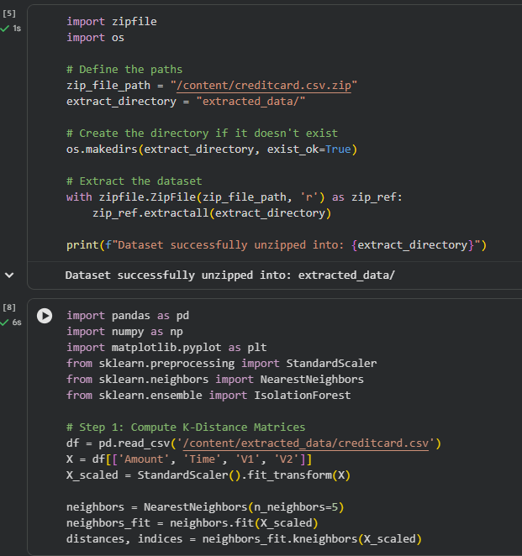
- Step 2: Establish Density Thresholds Sort and plot the calculated neighbor distances. Identify the point on the curve where distances increase sharply, setting a clear threshold to flag isolated data points.
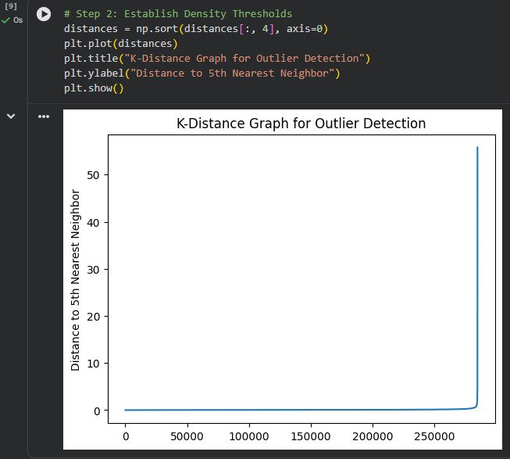

Phase 2: Tree-Structured Isolation Modeling
- Step 3: Instantiate the Isolation Forest Initialize Scikit-Learn’s IsolationForest classifier. Configure the model’s contamination parameter to match your target anomaly expectation (e.g., 0.01 for a 1% expected outlier rate).
- Step 4: Fit the Isolation Pipeline Run the model to isolate observations through randomized feature splits. Score each transaction; shorter path lengths within the decision trees indicate points that are highly vulnerable to being flagged as anomalies.
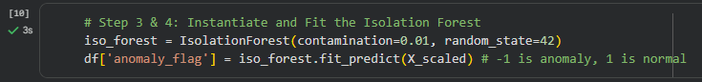

Phase 3: Diagnostic Validation
- Step 5: Cross-Reference Outlier Labels Compare the anomaly flags generated by the distance-based methods with those from the Isolation Forest model using a cross-tabulation matrix.
- Step 6: Map Anomaly Distributions Generate scatter plots of your data, highlighting flagged anomalies in a distinct color. This allows you to verify that the model is correctly identifying points outside normal operational clusters.
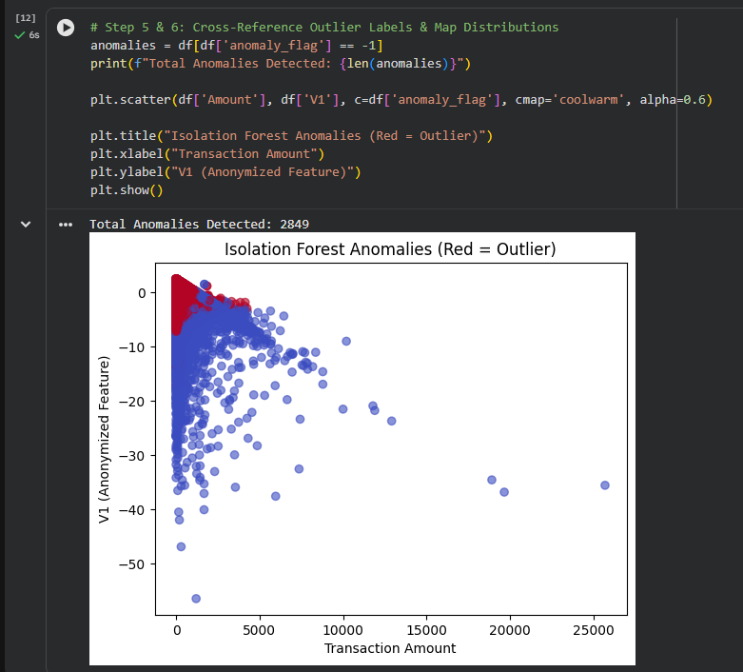

Lab No 14
Data Scraping & Sentiment Analysis

Overview & Real-World Problem
Modern consumer sentiment shifts rapidly across digital ecosystems, forums, and social channels. Companies that rely only on lagging indicators like quarterly focus groups miss immediate changes in brand perception, leaving them slow to respond to emerging public relations challenges or product quality issues.
The Solution: This lab constructs an automated NLP text processing pipeline. You will learn to extract raw text data directly from online platforms, preprocess unstructured string fields, and apply automated Sentiment Analysis to transform qualitative commentary into quantitative brand metrics.

Dataset Profile
The workflow generates and evaluates a Social Media Feedback Stream.
- Dataset Source: Programmatically scraped online product review tables.
- Core Attributes: Raw unstructured text fields, user handles, view counts, and time matrices.
- Target Targets: Cleaned token streams, text polarity scores, and categorical sentiment bins (Positive, Neutral, Negative).

Software & Analytical Environment
- Data Extraction: Python, using BeautifulSoup and Requests for web scraping.
- Natural Language Processing: NLTK or TextBlob for tokenization, stop-word removal, lemmatization, and lexicon-based sentiment scoring.

Practical Objectives
By completing this lab, you will be able to:
- Extract web data using parsing libraries.
- Sanitize raw text using tokenization, normalization, and stop-word filtering.
- Apply lexicon-based scoring engines to calculate text polarity.
- Classify text feedback into structured sentiment categories for dashboard reporting.

Step-by-Step Procedure

Phase 1: Web Scraping & Ingestion
- Step 1: Extract Web Target Raw Data Use Requests to retrieve the HTML structure of a targeted product review page. Use BeautifulSoup to locate specific text containers, extract raw user comments, and organize the output into a structured data frame.
- Step 2: Profile Text Characteristics Audit the raw string entries to assess the volume of non-text noise, including HTML breaks, special characters, and emojis.
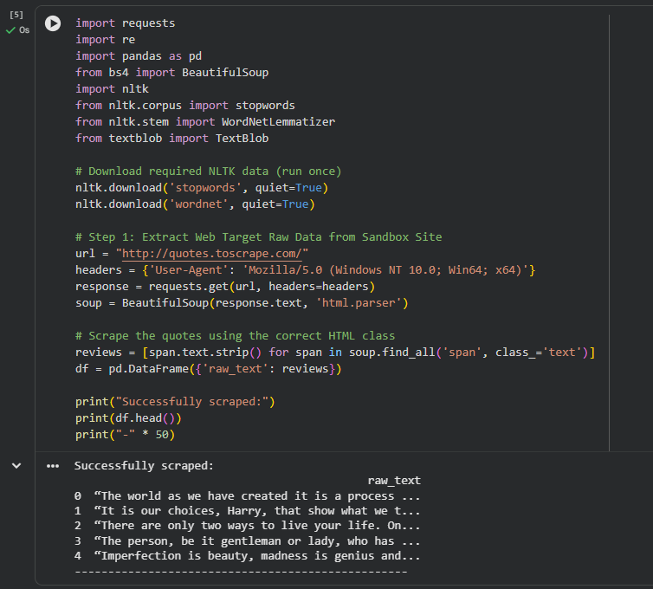

Phase 2: Text Preprocessing
- Step 3: Clean the Text Stream Use regular expressions (re) to strip out URLs, HTML tags, and numerical artifacts. Convert all text strings uniformly to lowercase.
- Step 4: Tokenize and Filter Stop Words Break down sentences into individual words using tokenization modules. Filter out common stop words (e.g., "and", "the") using pre-built NLTK dictionaries, and apply lemmatization to reduce words to their base form.
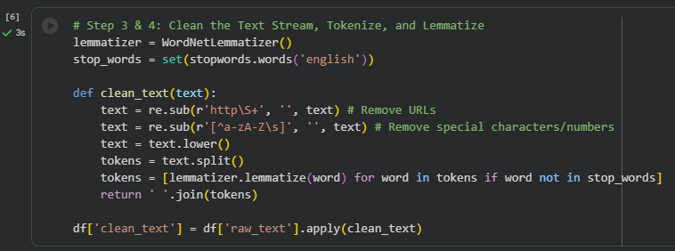

Phase 2: Sentiment Modeling
- Step 5: Compute Text Sentiment Scores Pass the sanitized text tokens into your sentiment analyzer engine. Calculate an overall polarity score for each comment, bounded strictly within a range of -1.0 (highly negative) to +1.0 (highly positive).
- Step 6: Classify and Aggregate Sentiment Bin the numeric polarity scores into distinct categories: Positive (score > 0.1), Negative (score < -0.1), and Neutral. Calculate the relative proportions of each category to establish baseline metrics for brand health.
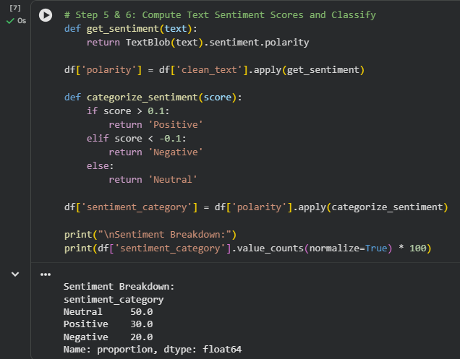

Lab No 15
Performance Comparison of Models

Overview & Real-World Problem
Enterprise decision-makers rarely rely on a single data mining model without verification. Because different algorithms excel under different data conditions, deploying a single model without testing alternatives can lead to suboptimal performance, increased costs, and missed business opportunities when applied to production data.
The Solution: This comprehensive capstone lab implements a structured, multi-model evaluation framework. You will process a real-world dataset through a complete data science pipeline from preprocessing to modelling and evaluate multiple machines learning classifiers side-by-side to select the optimal model based on operational KPIs.

Dataset Profile
The capstone evaluates a high-dimensional Omnichannel Enterprise Churn & Revenue Dataset.
- Dataset Scale: 35,000 unified corporate records.
- Core Attributes: Combined demographic, financial, and behavioural attributes containing missing values, uncalibrated continuous scales, and categorical features.
- Target Objective: Predict account attrition while optimizing overall operational accuracy.

Software & Analytical Environment
- Development Architecture: Python, utilizing the full suite of data processing and machine learning libraries (Pandas, NumPy, Scikit-Learn, and Seaborn).
- Algorithmic Inventory: Decision Trees, KNN, Naïve Bayes, and Support Vector Machines (SVM).

Practical Objectives
By completing this lab, you will be able to:
- Construct a comprehensive data mining pipeline from scratch.
- Resolve diverse data issues simultaneously, including missing values, skewed distributions, and categorical encodings.
- Deploy multiple classification models across identical cross-validated partitions.
- Compare algorithmic performance using visual ROC/AUC charts and metric matrices to select the best production model.

Step-by-Step Procedure

Phase 1: Unified Preprocessing & Pipeline Pipeline
- Step 1: Sanitize and Prepare Data Load the multi-dimensional dataset into your workspace. Identify and handle missing rows, strip out duplicate entries, use label encoding on categorical variables, and apply Min-Max normalization to standardise continuous numeric scales.
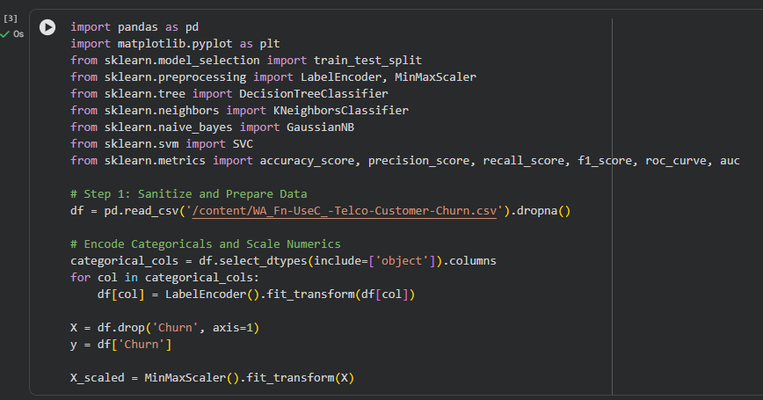
- Step 2: Partition Cross-Validation Splits Divide the preprocessed dataset into structured training and testing sets, using stratified splitting to ensure the target variable's class balance is maintained across subsets.

Phase 2: Framework Modeling Execution
- Step 3: Train Selected Classifiers Train each of your core models on the prepared training dataset:
  - Configure a Decision Tree Classifier with depth constraints.
  - Initialize an optimized KNN Classifier.
  - Fit a Gaussian Naïve Bayes model.
  - Train a high-dimensional Support Vector Machine.
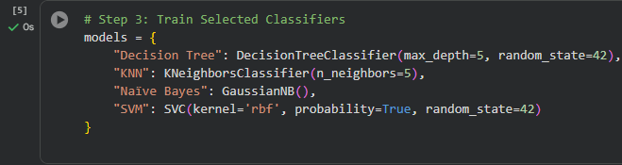
- Step 4: Generate Model Predictions Process the test data through each trained model to output target class classifications and prediction probability arrays.
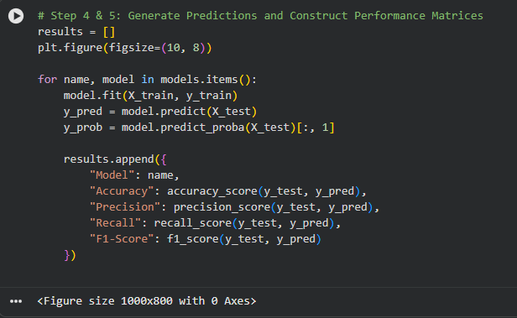

Phase 3: Comprehensive Model Benchmarking
- Step 5: Construct Performance Matrices Compute Accuracy, Precision, Recall, and F1-scores for all four models. Consolidate these results into a single performance matrix for a direct, side-by-side evaluation.
- Step 6: Map ROC Curves & Select the Production Model Plot the Receiver Operating Characteristic (ROC) curves for all models on a single graph. Compare the calculated Area Under the Curve (AUC) scores alongside processing time metrics to identify and select the best overall model for production deployment.
